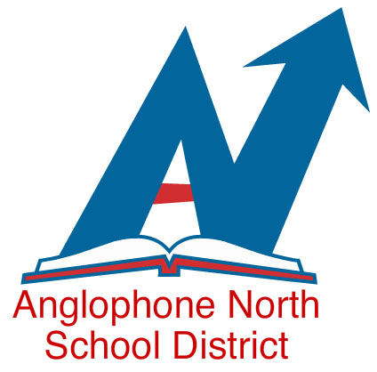
“Everyone at Their Best” Parent Information Meetings
French Second Language Programs
_{For the 2025-2026 School Year}

Information on registration and an overview of the programs are available on the ASD-N website through the following link: “Registration”

Before registering your child, we ask that parents review the information posted to the ASD-N website, including a voice-over PowerPoint prepared by EECD titled “Everyone at Their Best Storyline”.
This year we will be hosting 2 virtual Q and A sessions for parents. To be able to participate in the virtual sessions, parents will have to download Zoom. Information will be provided on the following French Second Language Programs available in Anglophone North School District:
- Grade 1 Entry Point (Early French Immersion)
- Grade 6 Entry Point (Late French Immersion)
- Grade 5 Intensive French Program
Date | Time | Zoom Link
Thursday, January 30th, 2025 | 6:30 pm | Join Zoom Meeting  https://us06web.zoom.us/j/88116080766?pwd=5PDqMspaTDZtKpQq6IvETd7benSUs6.1  Passcode: 2LFEix
Monday, February 10th, 2025 | 4:00 pm | Join Zoom Meeting  https://us06web.zoom.us/j/83646622018?pwd=ipbAP0HdPvreyjaZspHeXIisrbbHx0.1  Passcode: 9GAifK

Parents who wish to enroll their children in the Grade 1 or Grade 6 Entry Point French Immersion Programs for the 2025-2026 school year will be required to complete the electronic registration form located on the ASD-N web site:
http://asd-n.nbed.nb.ca/
Deadline to register is April 10th, 2025.
The following link to the EECD French Second Language website may also be helpful to you:
https://www2.gnb.ca/content/gnb/en/departments/education/k12/content/anglophone_sector/fsle.html

For additional information, contact your local school or
Linda Dickson (French Second Language Programs Coordinator) 778-6844

