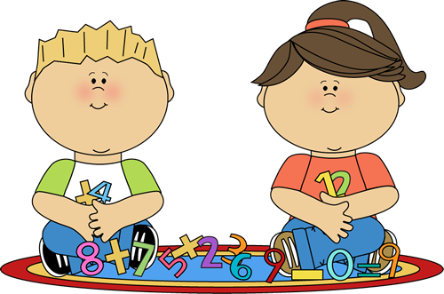 Guess My Riddle 

I am a shape.

I have 4 sides. 2 are long and 2 are short.

I can be a table, a door, a mat or the floor.

What am I?

Can you find 4 items this shape at home? What are they?