Thursday Home Learning Schedule
Grade 3 FI Raiders Tuesday Schedule
Word Work
Students can do word work.
Les mots
Les mots: j’ai, suis, elle, il, peux, peut, avec
Grab some markers and do your words: en arc en ciel, pyramide crayon, stylo, marquer
-write the word in white crayon-colour over it.
Have fun and use your imagination
Writing
Students can grab a piece of paper. Try putting the words of the week in sentences: J’ai regardé un film hier soir. Je suis allée chez mes grandparents avec ma sœur. Elle s’appelle Kailey, et il s’appelle Dexter. Je peux faire mes devoirs et il peut faire aussi !

Gym
Students can do a physical activity of their choice.
Literacy
Students will do 4x 15 minutes rotations. Set a timer to keep track!
Avec mme:
- Students can log into Boukili read or listen to books: class code:qy8qht
À soi: Chasse au trésor : la nature
Boom!
- Students can log into BOOM class code. Reach out if you need their log in information
Centre d’écoute
- Students can log into lalilo. This is an excellent resource for les sons : class code:HZJPKV

Math
Students can log into ZORBITS.
I have also attached a work sheet: Position Des Chiffres.
They need to look for what position the question is asking for: centaines, dizaines, unites. (Hundreds, tens, ones) and write in the correct number.
Any questions please reach out
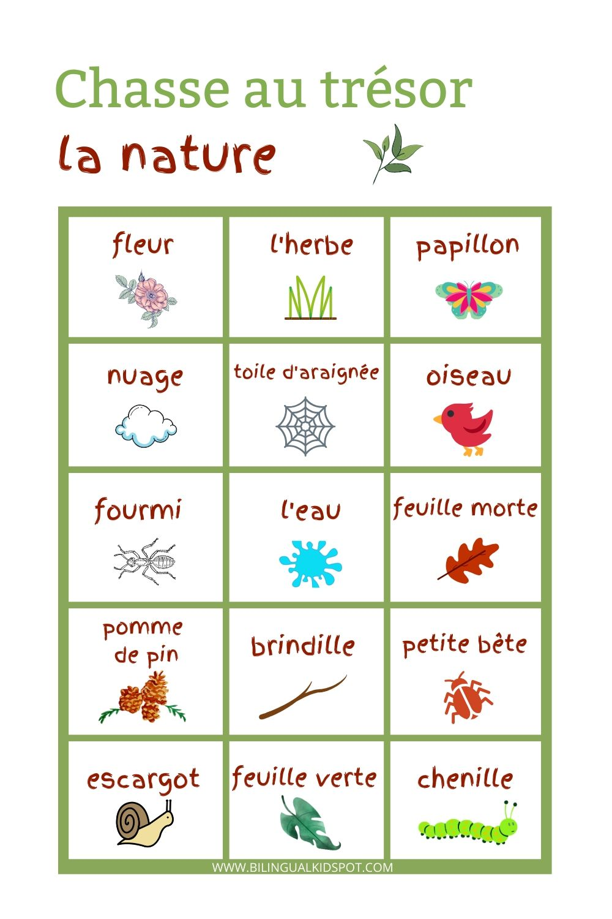
Try doing Mini Yoga, and then head outside for a nature scavenger hunt:

