Social Studies: Week 6 Social Structure in the Middle Ages

The Middle Ages lasted from about 500 to 1500 and was a period of time between ancient and modern times. There were many changes in society of what is now known as England. England is bordered by the North Sea, the English Channel, the Celtic Sea and the Irish Sea and is a part of an island that includes Scotland and Wales. Ireland is an island to the west of England. These large islands and those smaller islands around them are known as the British Isles.
*On a map or globe (or internet), find England and note its relation to Ireland and France. Notice that it is separated from France by the English Channel.
Many different peoples lived in the British Isles during the Middle Ages. The Celts were the first peoples who lived in Ireland, Scotland and Wales. Around 500, groups of people from Denmark and northern Germany moved in and settled in England. These were known as Anglo-Saxons. In 1066, an invading army of Normans from France defeated the Anglo-Saxons and took control of the country.

Every society has a social structure or system of how people in a community relate to one another. Each person has a role in society that affects how they live and interact with others.
The Normans had a social structure consisting of three social orders: the clergy(members of the church such as priests and bishops), the king and nobles(those who fought to protect society) and the peasants(those who worked to produce food for all).

Roles and Responsibilities of each order:
The clergy: The clergy’s responsibility was to pray for all members of society and to take care of the spiritual well-being of the people. They performed important ceremonies such as baptisms and funerals. Some were bishops or abbots who were in charge of large buildings called convents for those women who wished to become nuns. Members of the clergy wore a special form of clothing and did not marry.

The King, Nobles and Knights: This order had the responsibility of protecting the people and the society from invasion by enemies. The king granted land to the nobles or lords in return for protection and service. The lord’s knights or soldiers were trained to fight on horseback and use swords, shields and lances. Knights had to show bravery and skill in battle as well as good manners and to treat women with respect(rules of chivalry). Chivalry comes from the French word “cheval” meaning horse.

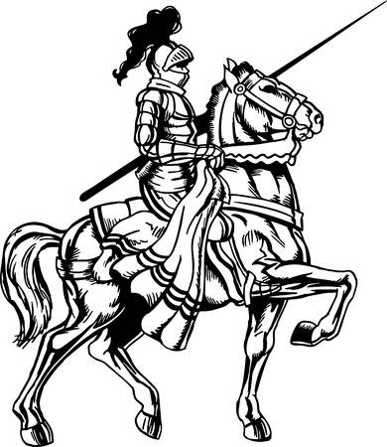
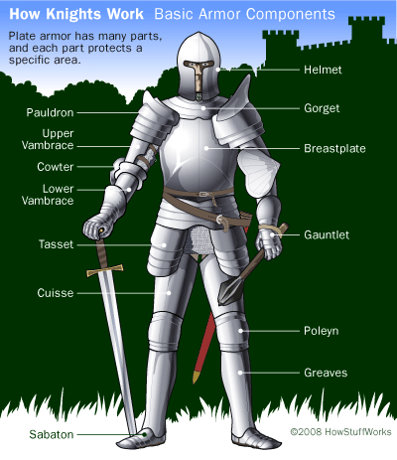

Knights wore a type of armour known as chain mail, made of small metal rings woven together for protection in battle. Later, knights wore plate armour over the chain mail for added protection. Plate armour was more expensive because it had to be custom made to fit each knight. The head gear had tiny slits or narrow holes in it enough for them to see but small enough to protect their eyes from an attacker’s sword.

The peasants: This order included those who worked in the fields to provide food for society. Most of these people were farmers who rented land from the lords. They paid rent in the form of service to the lord. Some also became skilled in trades such as blacksmiths, millers, coopers, bakers or shoemakers. Some family names date back to the Middle Ages, since many were named after the trade they practiced, for example “Smith” coming from blacksmith or goldsmith.

Social structure influenced people’s daily lives and their lifestyles were different depending on the social order to which they belonged. The centre of life for most of English society was the manor or land that belonged to the lord (demesne) and the land that the peasants rented from the lord.

Life of a Lord
At the centre of the manor was the castle or manor house where the lord and his family lived, along with his servants and knights. Surrounding the castle were forests, pastures and the village where the peasants farmed. Boys left home as young as age seven to begin training to be knights. Girls were educated in convents but also learned to hunt and ride horses.
The castle was built to defend its people from attack and had thick stone walls with a ditch or moat surrounding it. The moat (often filled with water) made it difficult for enemies to reach the castle. Inside the castle were buildings for animals, servants, the lord’s family and knights. The castle also had a kitchen, cellar, pantries to store food and a prison. The centre of the castle was the great hall where the lord ate and entertained guests. Nobles passed the time dancing and listening to music by harpers. Adults also passed the time playing games such as chess and hunting. Children played with toys such as dolls and whistles.

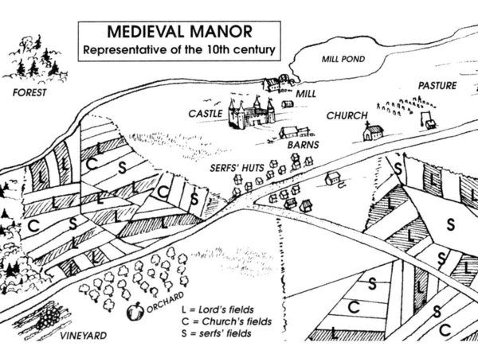

Activity 1: Imagine you are a lord and have to design a castle to protect your family and servants. What important features will it have? What will it look like on the inside? What will it look like on the outside? Will it have a moat surrounding it to keep enemies from reaching the castle? Make a drawing of your castle and the forests, fields and village surrounding it. Label each area of your drawing to show the different people living in the community. How does each group of people help each other to survive?

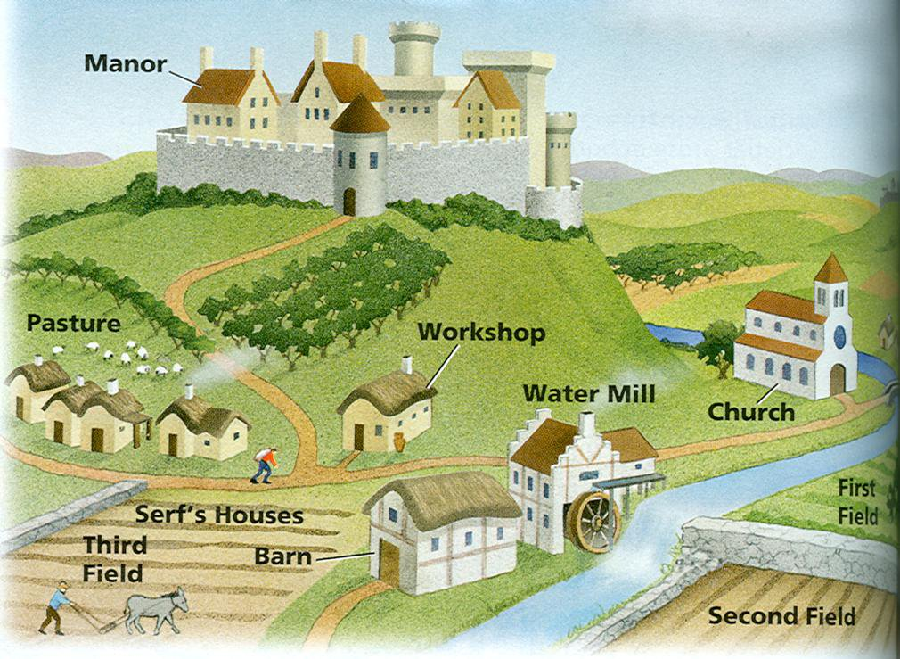

Activity 2: Compare the different roles of people in middle age society to those of people in our own society today. What things are similar (the same)? (those who work in service industries, farmers, etc.) What things are different? (way of life, activities, etc.) In what ways do both societies help its people function or survive? (provide food, protection, etc.) Do you think the quality of life has improved in today’s society? Explain and give examples to support your ideas. Discuss with a family member.

