Family Names and Crests
We have learned that many family names came from the type of work or job members performed in the past such as “Smith” for those who were blacksmiths making horseshoes or iron tools or “Miller” for those who would ground wheat to make flour.
Activity 1: Research your family crest
Think about your family name or the family name of a close relative. Do you know the origin of your family name? Discuss with a family member and do some research if needed to find out where your ancestors lived and some interesting facts about the culture. Do you have any family traditions that relate to your heritage? Does your surname(family name) have a crest?(research on the internet if necessary) What meaning does the family crest have(motto)?

Here is the family crest for my Irish surname Doyle (Dubhghaill). Its motto means “Strength Conquers All” and the images are used to represent the family name. The surname Doyle is of Norse origin and Doyles are the descendants of Danish Vikings. The name comes from the Irish “Dubhghaill” meaning “dark stranger” referring to a “dark haired foreigner”. “Doyle” is the Anglicised(English) version of the Irish “Dubhghaill”. Doyle is a common Irish surname that is very common here as well.

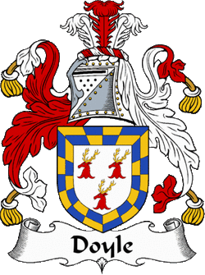
Activity 2: Create Your Own Family Crest

On a blank sheet of paper, do a draft copy design of your own creative family crest. Decide what images you would like to use on your crest that represents something you are proud of about your family(for example, brave, kind, loving, caring, calm) You may choose any animals, objects or images to design your crest. Make sure to leave a ribbon space or area for you to write your family name in large letters that will stand out. When you are ready, do a final copy of your crest, colour it and share it with your family and friends. You may want to put it on display in a frame or on a bulletin board.

On a separate sheet of paper or on the back of your final copy, write a description of your crest indicating what the images stand for or what meaning each conveys. Give your new family crest a motto or positive phrase(examples: “Of kind heart and courageous spirit”, “Determined and brave” or “Loyal friend and helpful hero”.)

Have fun! You may wish to share your creations live at our class meetings or take a photo to share.

