Science: Week 5 Design and Test a Heat Insulating Product

An insulator is a material that does not conduct heat very well. A thermal insulator is good at keeping things hot or cold. Think about putting on wool socks in winter after a warm bath. This keeps the heat from escaping, keeping your feet cozy and warm. Think about your grandma’s tea cozy. It keeps the pot of tea warmer for longer as it sits on the table by trapping the air around the object, preventing heat from escaping.

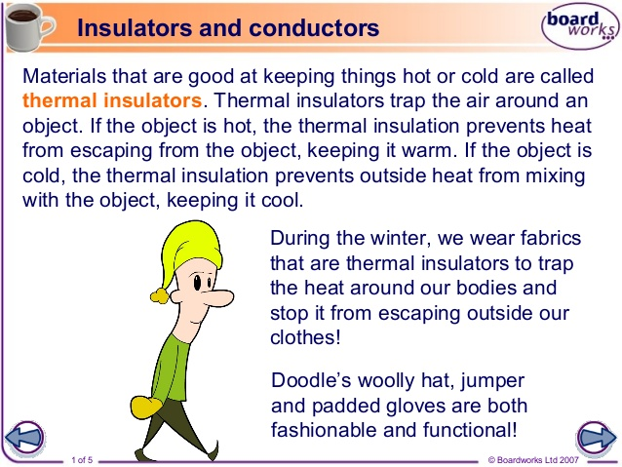

Activity 1: Conducting a Fair Test
A fair test is when explorations are carried out under strictly controlled conditions so that the results are reliable. All factors or variables that can affect the results are controlled except the one that is being investigated. So for example, to test a material for its ability to be a good insulator, all other factors need to remain the same except the type of insulator used.
Try this test to see which insulator is the best at keeping a bottle of water warm(keeping it from losing heat).
You will need: three or more containers or water bottles with caps (all the same size), hot water, masking tape, scissors, a thermometer or digital thermometer, a timer or stop watch, three or more different materials to wrap around the bottles to test as insulators(examples: aluminum foil, wool sock, newspaper, plastic bag) 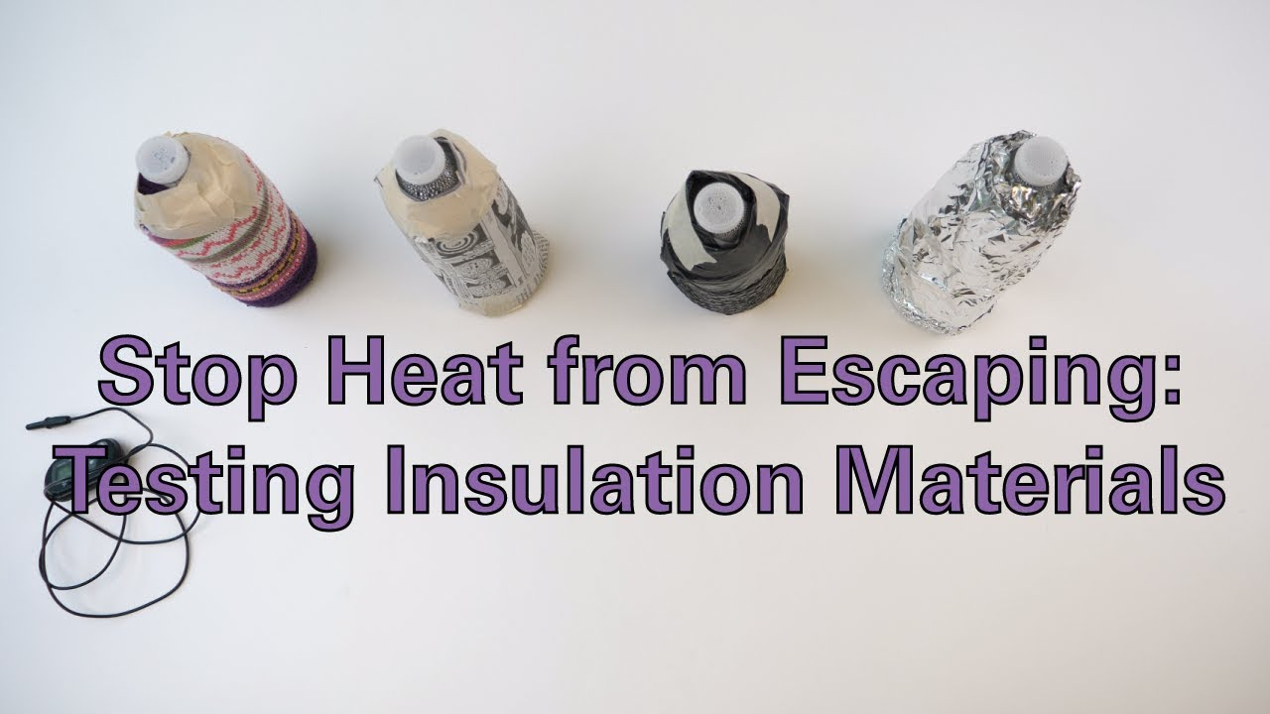

- Wrap each bottle with each of the types of insulator.
- Pour the same amount of hot water into each bottle(ie. fill it up)
- Record on a piece of paper, the temperature of the water in each bottle.
- Put the caps on the bottles to seal them.
- Set a timer for 15 minutes.
- Take the caps off the bottles and record the temperature of each again.
- Record which bottle lost the least amount of heat.
- The insulator around the bottle that lost the least amount of heat is the best. Were you surprised at the results?

Activity 2: Design and test a heat insulating product of your own.

Think about what materials you could use to create a heat insulating product of your own to keep a drink warm while it protects the user from heat.(Think about why sometimes your Tim Horton’s hot chocolate is too hot to hold. They may need your help!)
Maybe you’d like to design something to keep your cup of hot chocolate at home warm as you read your favourite book or watch your favourite movie.
The test you did above on different insulators may help you plan which material to use. After you create your drink insulator, give it a cool name (haha) and write an advertisement, make a commercial or design a drawing to sell your new invention!

