Home Learning Week 8
May 25 – 29

Language Arts
- READ …. Every day! You can read a chapter book, a picture book, a magazine, newspaper…whatever is enjoyable for you! There are also tons of books online for you to access.
- Scholastic has a wonderful site where you can read and learn so many interesting things! I am so impressed with the content on this site! If you haven’t checked it out, you really should! http://scholastic.ca/kids/thingstodo/
- RAZ kids is also a great site where you can find levelled books. www.raz-kids.com
- Try to find a reason to write at least a few times a week! Maybe you could write a letter to me! I would love to get mail from you! You can send it by email to angela.woods@nbed.nb.ca. And I promise I will write you a letter.
- Make a “bucket list” for the summer! What are some things you would like to do, see, create…places you would like to visit (within New Brunswick!)
- Which lead me to: do some research about our beautiful province! Search online for things to do in New Brunswick. Choose a fun thing to do in NB and make a poster about it! * if you Google “New Brunswick tourism” you will find all kinds of information!
- Don’t forget to log onto Amira for some reading practice
- Practice some cursive writing…can you write all of your family member’s names in cursive?

Math

- Practice skip counting by 3’s, 4’s 5’s 10’s and…25’s! Can you skip count forward all the way to 500? If you can, try skip counting BACKWARD from 200.
- Try this practice sheet: https://www.worksheetfun.com/Skip%20counting/skipcounting_2_12_wfun_2.pdf

- If you like working on worksheets, this site has lots of free practice sheets for you to print off:
https://www.worksheetfun.com/

- Visit brainpopjr and watch the video about fractions:
https://jr.brainpop.com/math/fractions/basicpartsofawhole/

- Try these practice pages: https://www.superteacherworksheets.com/fractions/fraction-shapes_TWQTQ.pdf?up=1583155146 and
https://www.superteacherworksheets.com/fractions/fraction-shapes-2_WERTY.pdf?up=1583155151

- Keep practicing the multiplication tables! Try working on the 5 times table this week. It’s just like counting by 5’s!!
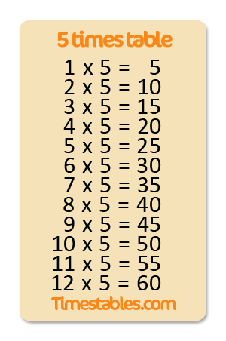

Additional Ideas From Our District Literacy Leads:
Grades 2 & 3
Reading & Viewing Writing & Representing Speaking & Listening
Write the main idea from a book, magazine or newspaper article that you are reading.  The RAAP Strategy  Read the book, magazine, paragraph or article.  Ask yourself, “What is the main idea in what I read?”  Ask yourself, “What are the important details?”  Put in writing the main idea and details in your own words. | Keep a journal of daily signs of spring. Write down any changes you notice outside from day to day. Are there buds on the trees yet? Have any flowers sprouted or grown taller? Add illustrations to your journal to document the changes you see. Go outside and help someone rake the rocks and dried up leaves off the lawn. | After reading your book talk about your favourite part. Explain why it is your favourite part.
After reading your book, draw a new cover page. What do you think the characters look like? Are they different than the ones in the book? | Find a family heirloom or a meaningful family object (picture, dish, piece of art, photo). Draw a picture of the object or describe it. Write about why it is special to you and your family. Convince me why it is special. | Sing your favourite song to a family member. Remember to make up some dance moves too!
Does the book you are reading remind you of another book? Explain why or why not? | Write a letter or make a card to an essential worker to stay thank you. | Ask a family member to tell you a story, at the end retell the story to them.

