ELA: Week 6 Historical Journal Entry

Read the following article on the life of a peasant in the Middle Ages. Think about the role of each family member and how this helped the family to survive.

In the Middle Ages, people were born into one of the three social orders: King or nobles, clergy or peasants. People’s lifestyles depended on the social order to which they belonged. Life was extremely hard for peasants or those who worked to provide food for society. They farmed the lord’s fields and worked long hours just to pay rent. Some peasants learned a skill or trade such as millers or blacksmiths.
Peasants lived in a small cottage with one or two rooms, a clay floor and a thatched roof. Sometimes cattle were kept under the same roof next to the room where the family lived. Children often helped their mothers take care of the smaller animals such as chickens or geese and collected berries to make jam. They would work at a very young age alongside their parents, either working in the fields or as apprentices to learn a trade.
Peasant clothing was very simple and often grey or brown and they wore plain leather shoes. They wore tunics with belts and caps or head coverings. Only wealthier peasants could afford clothes lined with fur.
Holidays like Easter were celebrated as well as certain days of rest where they would enjoy leisure activities such as playing games, dancing and singing. In spite of such a hard life, peasants entertained themselves and had fun whenever they had the opportunity.

Activity 1:
Write a journal entry from the perspective of a child in Middle Age society. You may choose any of the social orders as the author of your journal entry. For example, a wealthy member of the lord’s family living in the castle, a page learning to train to become a knight, a peasant worker learning to how to farm or learn a skill. Tell about how you spent your day such as doing chores or work, playing games or relaxing. How is a day in the life of a child in the middle ages different from your life today?

Activity 2: Divide a sheet of drawing paper in two. On one side, show a drawing of a medieval child during the day. On the other, draw the same child as he or she is preparing for bedtime. Does his or her day look different than yours?
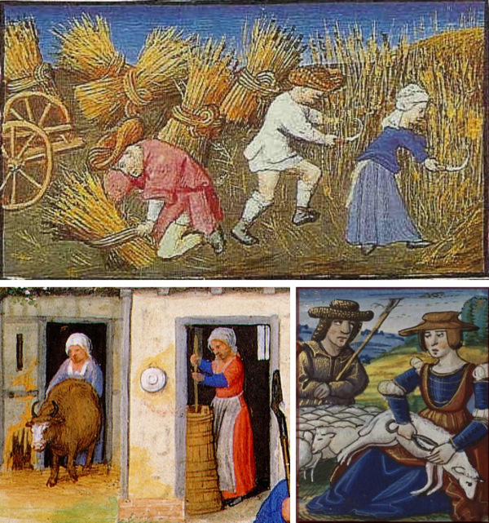

Medieval Peasant Cottage
