ELA Week 5: Genre Focus: Myths and Legends

If you love to read and even write your own stories, you may have discovered that you have a favourite genre. A genre is a type of art, literature or music that has a certain form or characteristics that are different from other types.
For example, a legend is a genre that usually contains heroic individuals or amazing places that have elements of historical fact but may not have been proven to be true.
One example is the legend of Robin Hood, a man who stole from the rich to feed the poor. His story has been retold over the years with information being added or changed and several movies have been made portraying him as a hero with unusual archery skills and keen ability to outwit his enemies. His story is timeless in that it shows that rather than being greedy, people should share wealth with others.
A myth often contains stories of powerful gods or creatures instead of stories of everyday human beings. Certain cultures have elements of this genre that influence traditions and customs. One modern example is the popularity of the Percy Jackson character who is part Greek god and part human. In this popular series which also became successful movies, Percy’s reading difficulties were due to his being part Greek god so he had a built-in ability to read ancient Greek. This idea points to the lesson that although we may have struggles in some areas, we should not overlook the fact that we all have hidden talents and abilities.
Activity 1: Read the following legend and look for some of the characteristics that make it unique. What do the characters’ actions say about them? Why do you think the story of King Arthur became a legend? What other legends do you know?
The Legend of King Arthur

In the 5th century, Britain was ruled by a High-King named Uther, who fell in love with Lady Igraine. However, she was already married to Gorlois, the Duke of Tintagel. King Uther was determined to marry Lady Igraine so he fought with Gorlois, killing him. He then married Igraine and they had a son, who they named Arthur.
This was a very dangerous time with many attacks and battles, so King Uther gave his son to a wizard named Merlin to keep him safe. Merlin sent Arthur to be raised in the countryside with his foster brother, Kay. Arthur grew up not knowing who his parents were.
When King Uther died, no one knew he had a son and many wondered who would be king. A mysterious stone appeared in the yard of Saint Paul’s cathedral in London. The stone had a sword in it with a message that said that whoever could pull the sword from the stone would be the rightful king of Britain.
When Arthur was fifteen years old, his foster brother Kay had his first knight’s tournament. They traveled to London but forgot Kay’s sword. Arthur went to look for one. He found the sword in the stone, and removed it easily. When everyone saw the sword, they wanted to know who had been successful in removing it. At first, they didn’t believe Arthur had done it. Arthur put it back in the stone and others tried to remove it but could not. Arthur took the sword from the stone and was crowned king.
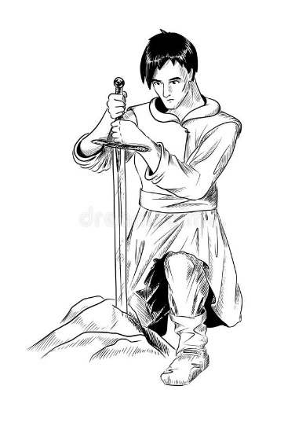
Activity 2: Research some popular myths or legends and choose one to read. You may wish to watch a movie or cartoon based on a well-known myth or legend with your family. What qualities about the genre did you notice in the story or film that tells you it is a myth or a legend?
Here are some examples to choose from: (make sure you have a parent’s permission first before you view the film)
