Science Week 9 Mix It Up

Can liquids and solids be mixed? Think about what kinds of matter you ate yesterday. If you had a salad with dressing, then you ate the answer to some important questions about matter. Almost everything in our daily lives is a solid, liquid or a combination of the two, such as a salad. A liquid dressing is poured over the salad ingredients such as lettuce, tomatoes and cucumbers.
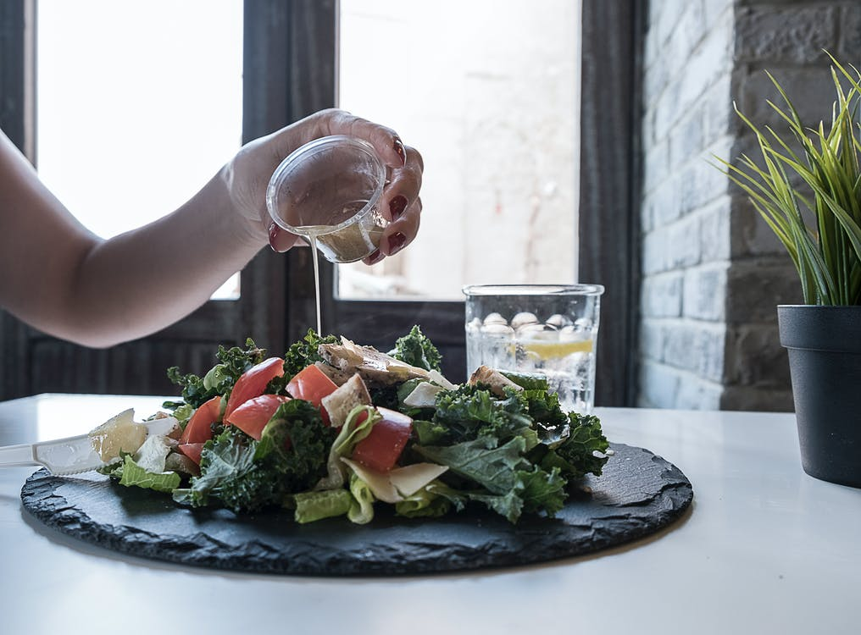

When you make instant hot chocolate, the packet contents mix with water to form a sweet brown drink. The solid cocoa disappears. Where did it go? It “dissolved” and became part of the liquid.

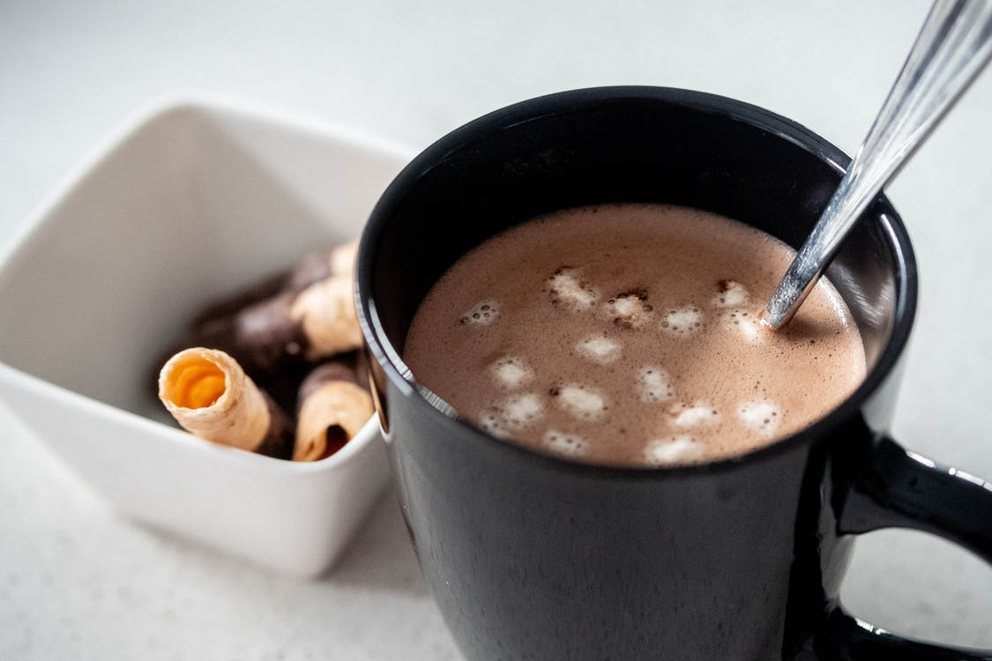

What dissolves in water?

Water can dissolve more types of solids than any other liquid. The water in our oceans is very salty because the salts dissolved in it were at one time parts of rocks and different soil. Not all solids will dissolve in water and will keep their shape, such as a plastic bottle. Plastic containers will not mix with water and these may build up in the ocean over time.

Just as some solids may dissolve in water, such as salt from soil or rocks, they also may be removed again from the liquid by evaporation. When water evaporates, it may leave salt mounds behind that came from ocean water.
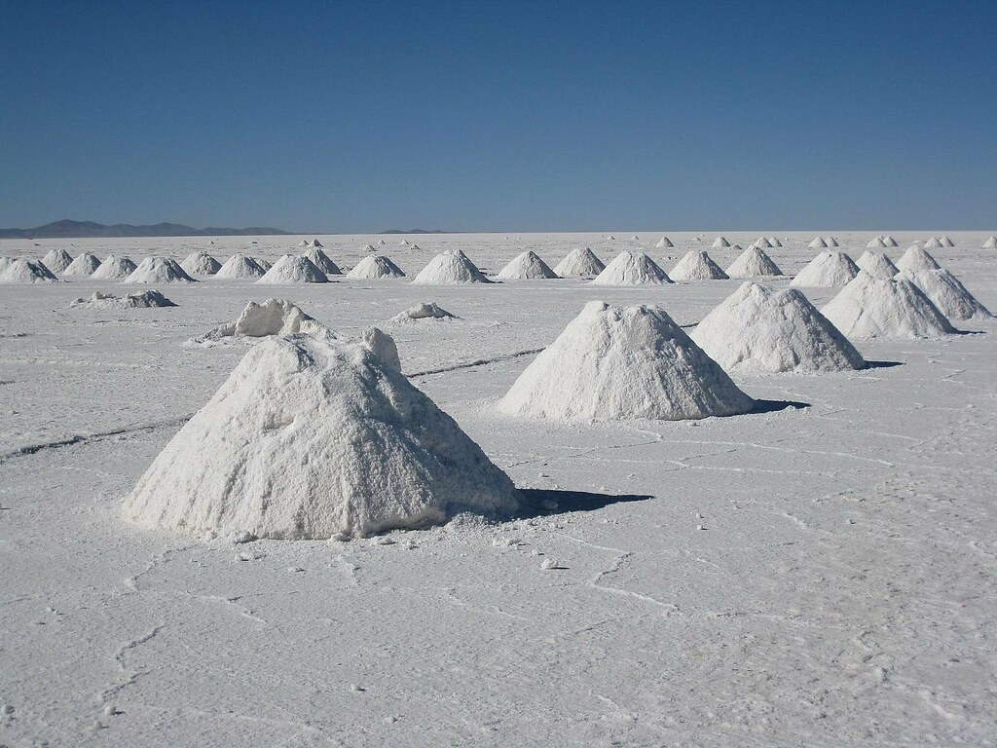
Activity 1: Does it dissolve?

You will need:
Samples of four small solids: salt, sand, sugar, rice
Four glasses of warm water

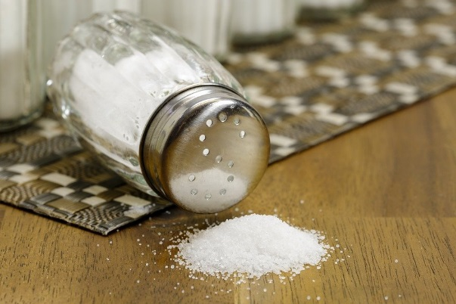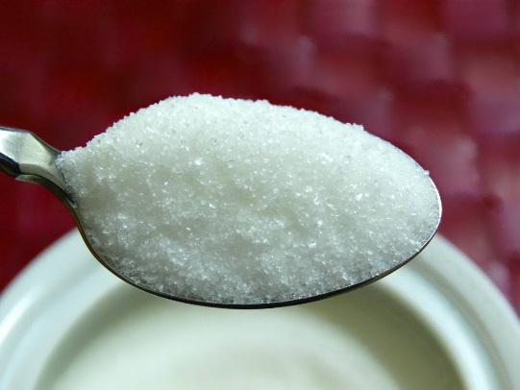

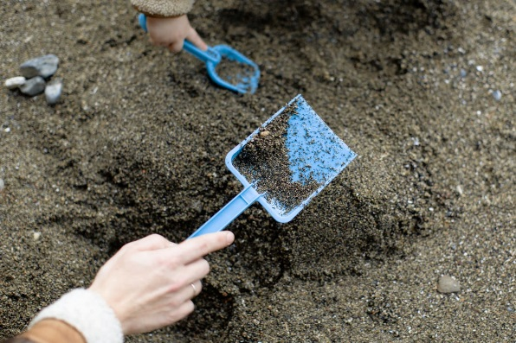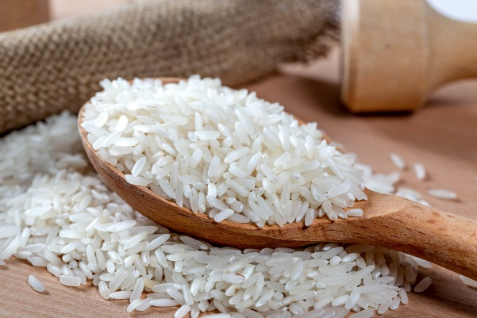

On a piece of paper, make a chart with the headings “Dissolves” and “Does Not Dissolve”.
One at a time, gently stir in each solid into a glass of warm water.
List your results with the name of each solid under the proper heading on your chart. What did you observe?

Can different liquids be mixed?

Some liquids when mixed together cannot be separated and mix together to form a new liquid, such as milk and coffee. Also, when you mix together two colours of paint, they cannot be separated again and instead form a new colour. For example, red and yellow paint when mixed together make orange.

Other liquids cannot be mixed together, and instead form layers when combined. The denser liquid sinks to the bottom and the least dense liquid floats to the top. For example, when you clean dirty dishes, the grease floats to the top of the dish water.

Activity 2: Floating Liquids

- Pour 125 ml of water into a clear jar.
- Add 125 ml of vegetable oil.
- Next, add 125 ml of maple syrup.
- Watch as the liquids separate.

Which liquid is the most dense? (floats to the bottom)
Which liquid is the least dense? (floats to the top)
Which liquid is in the middle?

