Social Studies: Week 4 Agriculture

We have learned many things about how the Nubians lived by studying artefacts and the geographic features of ancient societies. Agriculture was an important aspect of Nubian life as they found ways to create farmland, grow crops and raise cattle.
One method they used to water their fields was to dig shallow holes or canals to collect water and connect these to more trenches in the fields by opening and closing gates to allow water to flow through. They did this to irrigate (or water) the land.
Irrigate: to water land or crops using a system of pipes or channels.

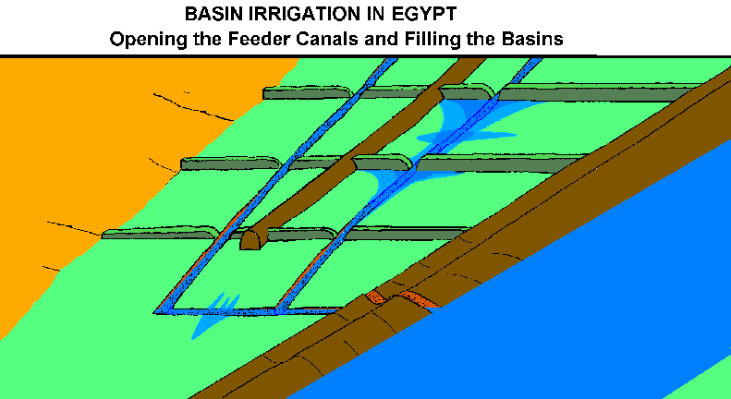

The Nubians could control the flow of water to the fields by opening and closing the gates at each entry point.
The Nubians cut down trees to create farmland. They may have cut down their forests faster than the forests could regrow. With no more tree roots and plant roots to hold the soil in place, it easily blew away. The once fertile land turned into a desert. Plants could no longer grow. This change is called desertification because without tree roots to hold moisture, the land becomes a desert.
Tree roots and plant roots hold moisture and hold soil in place. Over time, clearing of vegetation for farming can harm the soil. Fewer and fewer tree roots and plant roots cause water to evaporate quicker, leaving the soil dry and plants unable to grow.

Look at the diagram below to see how without proper care, over time, forests can turn into deserts.

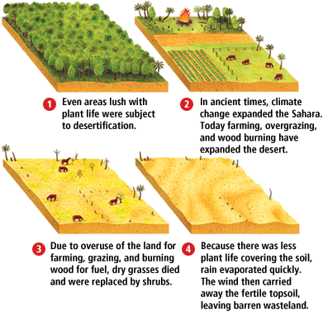
Activity 1: Draw a diagram similar to the one above showing what can happen over time if we cut down our forests too quickly and do not allow them to regrow. Divide your drawing into four sections, with your first drawing showing a lush forest full of trees and plants and your last drawing showing no forest at all. At what point in your four drawings do you think a difference could have been made to prevent desertification (when rich soil over time, becomes a desert)?

Activity 2: Discuss with a family member what things can be done to protect our forests and soil here in New Brunswick for years to come. Make a list of things that you can do to raise awareness and protect our forests for future generations. You may wish to create a drawing or poster to raise awareness or make a short video sharing your message with others. One person can make a difference by taking action to create positive change. It starts with you!

