Social Studies: Week 3 Making Inferences

We have learned that by studying artefacts we can make an educated guess (inference) about life in the past.

For example, by studying a food jar decorated with cattle used by ancient Nubians, we can infer that they created jars to store food, raised farm animals and grew crops such as grains and vegetables.
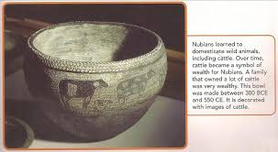

Activity 1: Study the following photos and make an inference (educated guess) as to what information each may convey about the past.
Photo 1:
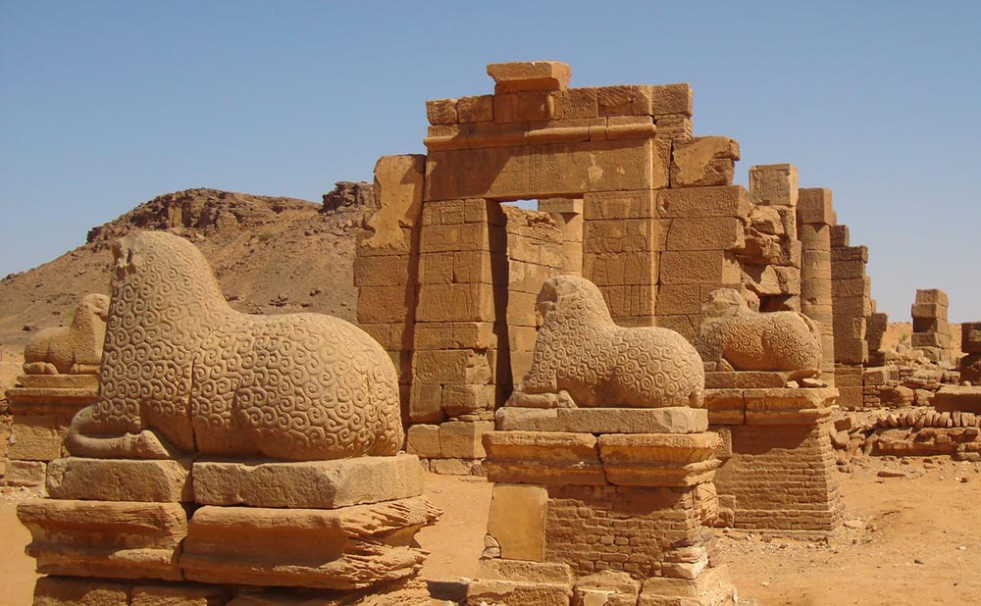
Archaeologists(scientists who study the past by digging into the earth to discover how people lived) believe that the earliest Nubian buildings were made of mud bricks baked in the sun to harden them for building.

What can you infer from looking at this photo?
Record your inference on a piece of looseleaf or tablet.

“I inferred that…………………………………………………………………………………………..”

Photo 2:
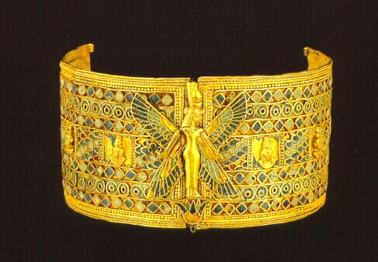
Gold was mined near the Nile River and in the desert in Nubia between 2000 BCE (Before Common Era) and 1500 BCE. Archaeologists have found grinding stones that were used to process gold. Gold was used to make jewelry such as armlets (worn around the arm) and gold was used to trade for other goods such as cattle.

What can you infer from this photo?

“I inferred that…………………………………………………………………………………………”
Activity 2: Historians and archaeologists do not always know the exact date when dating an artefact or event so they put a “c” before the date. The letter “c” stands for “circa” and means “around the time of”. Here are a few more photos that can give us information about the past. Can you identify the object and infer what it was used for or its purpose? Ask a family member if they can identify any or can provide any information on them. Research the object on the internet if you are stuck. Were your inferences correct? Now use the word circa or the letter “c” to date each of the objects shown. The first one is done for you.

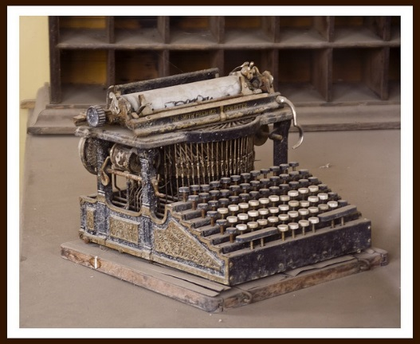
- Typewriter c.1800

2. 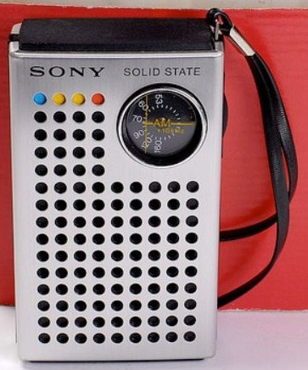
3. 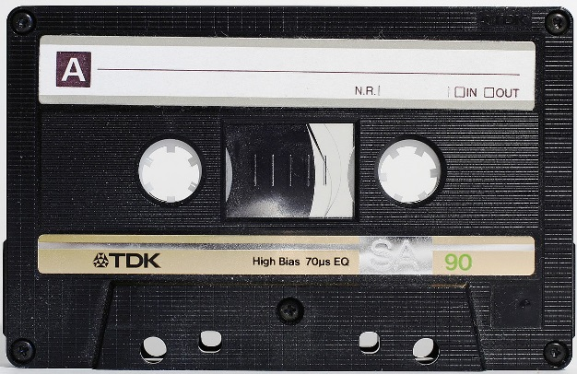

4.
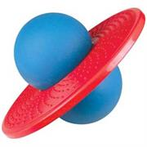

5. 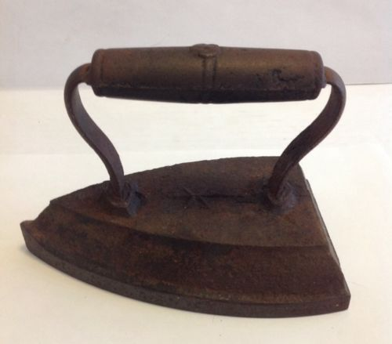 6.

7.

8. 