Science: Week 4 Matter and Changing States

We have learned that matter comes in three states: solid, liquid and gas. These can change from one state to another when heat is added or taken away. All materials have different melting and boiling points.

A melting point is the temperature that a solid turns to a liquid.
Example: A popsicle melting in the sun
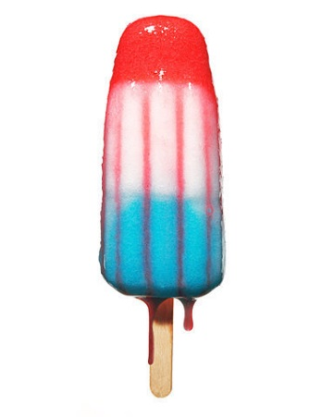The melting point of ice is 0 degrees Celsius.

A boiling point is the temperature that a liquid turns to a gas.
Example: Heating water in a kettle
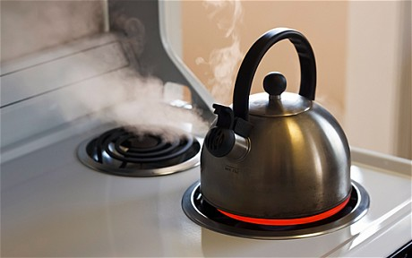 The boiling point of water is 100 degrees Celsius.
Even solids like rock and glass can turn into liquids. When you recycle your glass bottles, they are mixed with other materials and heated to a very high temperature so that they melt together and may be used to make new bottles, jars or building materials.

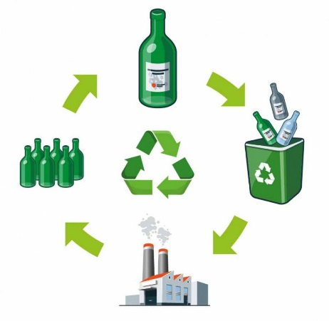Glass can be heated and mixed with other materials to form new glass bottles and even pavement for roads.

Matter can change from one state to another and back again.
Example: Lava from a volcano
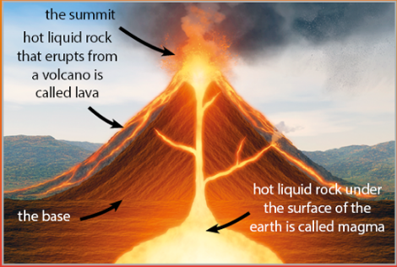 Lava, a liquid rock, flows down the sides of a volcano. It cools and will become solid rock again. Fun fact: The difference between lava and magma is that lava is the liquid rock that erupts from the volcano and flows down the sides and magma is the hot liquid rock under the surface of the earth.
Think of how ice can melt and change to a liquid and then freeze back to solid water again when the temperature drops. These changes are easy to see. But changes from liquid water to water vapour and back again may be a bit harder to observe. The process where water changes from a liquid to a vapour is called evaporation.
Tiny particles of water escape or evaporate from the liquid surface. Water vapour is a gas and mixes with other gases in the air. Evaporation happens faster in warmer conditions than in colder ones. Water vapour changes back to liquid water through condensation. Condensation is the process where water vapour changes into liquid water.
Example: When you breathe onto a window pane the vapour condenses on the cold glass. Your breath contains water vapour and when it reaches the colder air, it condenses and forms a cloud.

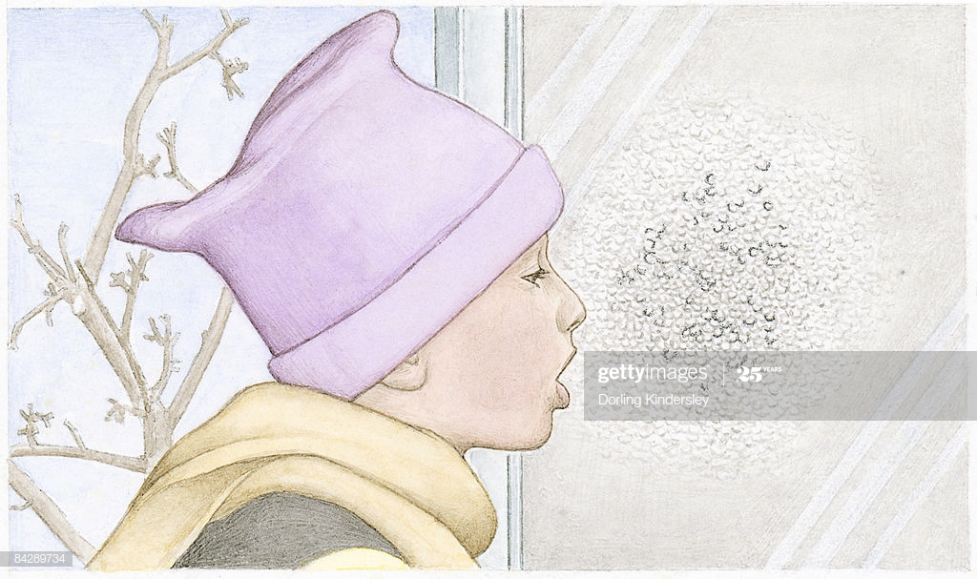

The water cycle is a good example of these changing states.
Water from rivers and oceans is warmed by the sun and evaporates. The water vapour rises to cooler air and forms clouds(condensation). The liquid falls back to the earth as rain or snow(precipitation) and the cycle repeats itself.

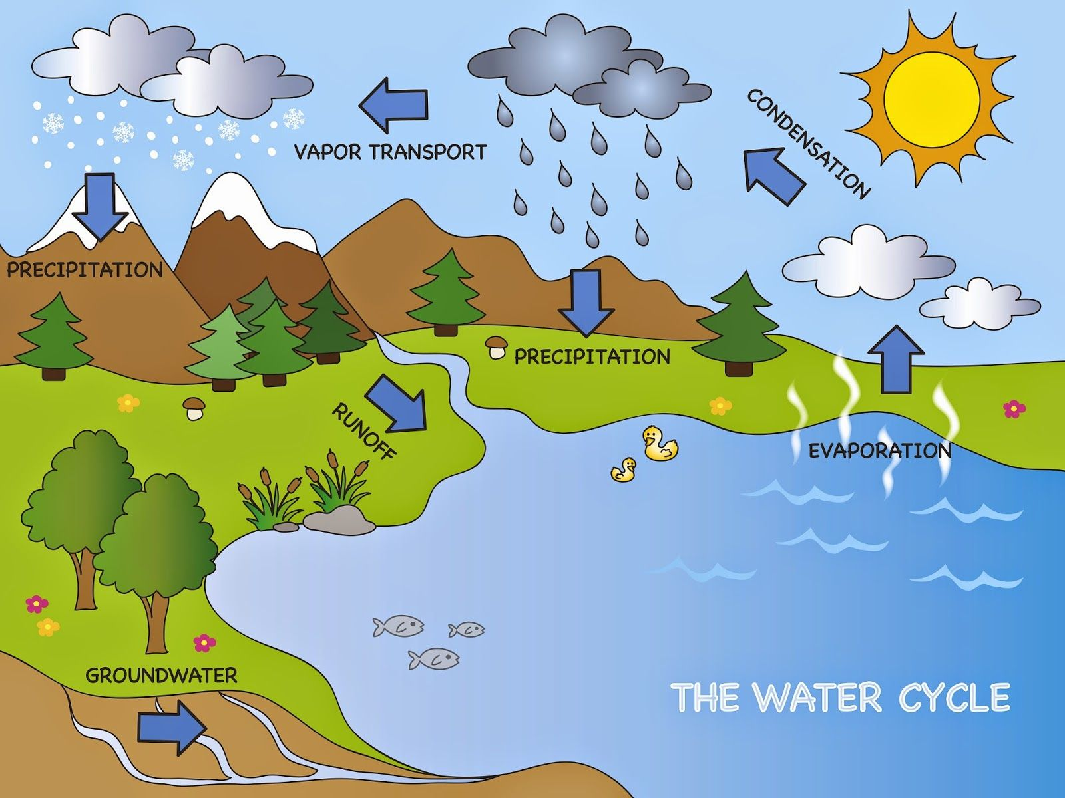

Activity 1:
a) Trace the steps of the water cycle in the above photo out loud by explaining in your own words how the process repeats itself. Start with the water in the river being heated by the sun which causes it to evaporate and travel upwards to cooler air.

b) See if you can use the terms you have learned to complete the following three phrases. Hint: Follow the process of the water cycle in the diagram to help you find the missing words.

Water in the ocean that is heated by the sun changes to a vapour through a
process called ____________________________.

The vapour forms a cloud and changes back to water through a process called
_____________________________.

The liquid falls back to the earth as rain or snow which is called
______________________________________________.

Activity 2:
Draw your own diagram of the water cycle. Colour and label your drawing using the terms evaporation, condensation, precipitation and any other helpful words. You may use the diagram above as a guide.

