Science: Week 3: Energy Use and Conservation

Energy is needed for our daily lives. It takes energy to grow our food, light our homes, cook meals, play video games and power cars. If we didn’t have enough energy, our lives would be very different. But, we need to think about where it will come from in the future.
There are two types of energy: non-renewable and renewable.
We get most of our energy from fossil fuels which took millions of years to form to become coal, oil and natural gas. Because these are being used faster than they can be replaced, they are called non-renewable energy sources. As well as becoming harder to find, they also release pollutants that harm the environment.
However, there are other energy sources that will not run out and so are called renewable energy sources. These include the sun, wind and flowing water.

Activity 1: Energy Survey
Think about how many times someone in your family tells you to turn out a light when you leave a room, not to leave the tap running while brushing your teeth, put on a sweater, take items to the recycle bin, shut the fridge door or turn off the television. Do you think that kids are more careful about energy use than adults sometimes? Do the following survey and then ask a family member to do the same and compare your answers.

- When it comes to saving energy I……….

- Deserve a high-five!
- Could improve
- desperately need a tutor!

- The best energy saver in my home is…..

- Me, of course!
- My parents/guardian
- Another household member

- When it comes to wasting energy, I’m most guilty of…….

- Leaving things on when I’m not using them
- Taking long showers or baths
- Travelling by car instead of walking or biking

Were you surprised by the results of your survey? Can you come up with some ways to save energy during the day? Write down three or more ways or choices you make during the day this week to conserve energy. If you make conserving energy a daily habit, it can really have a positive impact on your home and the environment.

You can even create a visual reminder for your family by drawing an object to represent each idea on a piece of paper and put it on the fridge or bulletin board. Example: A light switch or light bulb to remind everyone to turn out the lights when leaving a room, a rain drop or faucet for conserving water, the sun to remind you to play outdoors and turn off electronics, a pair of sneakers to remind you to walk instead of drive.
Colour your energy saving reminder poster with bright colours to be sure to catch the attention or your family members!

Activity 2: Create a public service announcement that encourages healthy habits or promotes energy conservation.

Here are four examples of public service announcement posters. What message is each one trying to send to the reader?

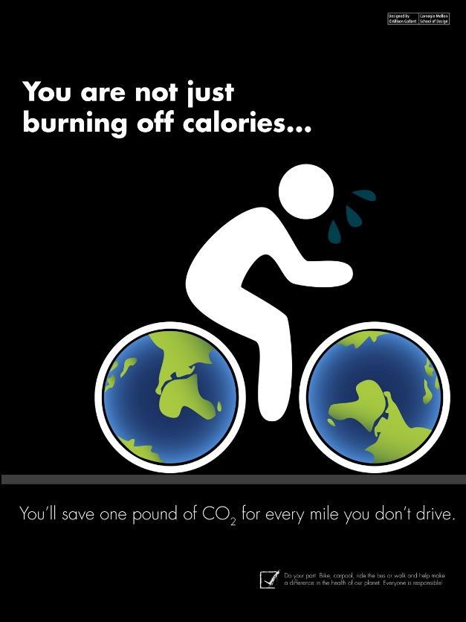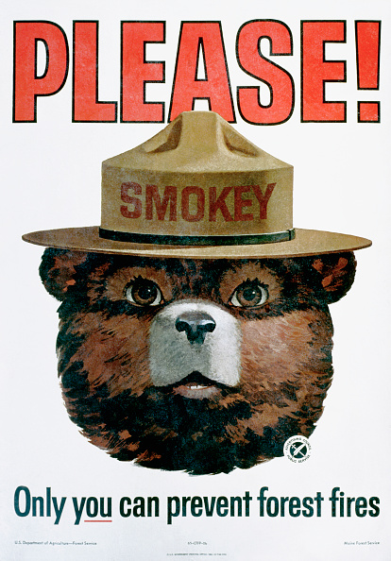

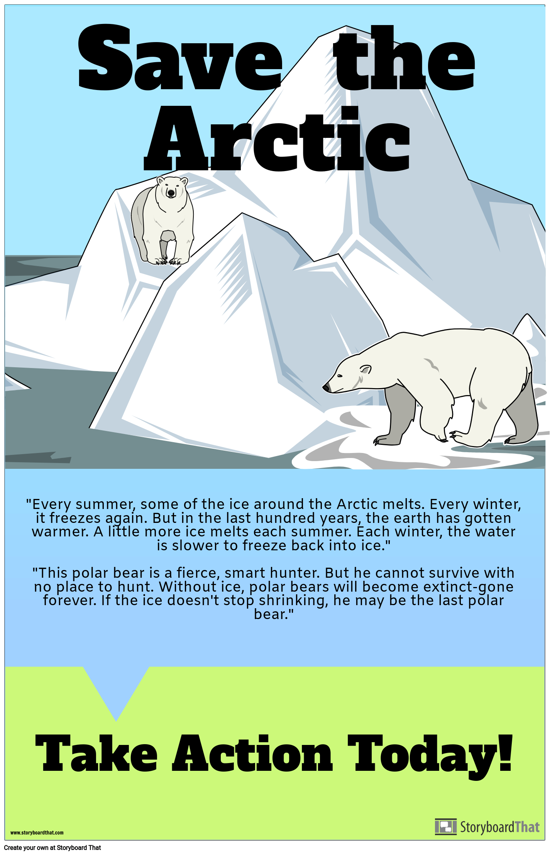

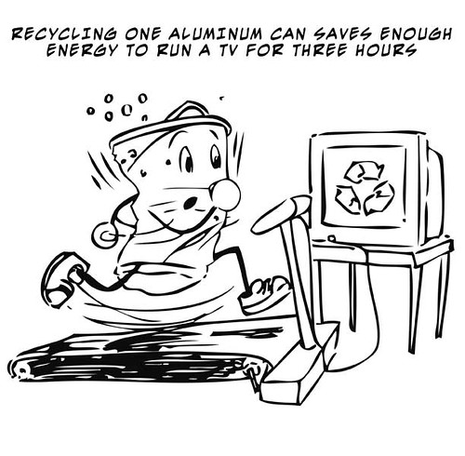

Now, it’s your turn!
Step 1: Choose one of the following topics: eating healthy foods, getting regular exercise or protecting the environment.
Step 2: Create a poster using images (drawings or pictures) and words (sentences that give positive messages and persuade others to take action) to capture the attention of the reader. (Examples: “The power of one!”, “Make your mark!”, “One step forward for a better future!”, “You can do it!”, “Let’s work together for a better world!”) Remember to use words that influence the reader to join in your cause. You can ask questions that help the reader relate as well in order to influence positive change or use catchy phrases that capture the reader’s attention.
Step 3: Share your message with family members and friends. You may wish to take a photo or save your poster to share with others.

