Home Learning Ideas April 20 – 25
Earth Day is this week so most of these activities follow that theme. Try some and, if you can, post a picture of you doing an activity on our Facebook page or email it to angela.woods@nbed.nb.ca.

- Most important of all….READ! Please try to read every day! It is so very important!
- Write a paragraph about your favourite thing to do outside in the Spring. Then go out and do it!
- Write a letter to someone you miss. If you have their address, mail it to them. If it’s someone in our class, I can help you with this. Or you could post it on our Facebook page.
- Video yourself reading a book out loud or a story that you wrote and maybe post it to our FB page!
- Make a list of things you can do to help take care of the Earth
- Pick up trash around your neighborhood or yard.
- Find some cool rocks and paint them. Keep them, give them as gifts or hide them for people to find.
- Using an empty can or container, decorate the container and plant some flower seeds in it!
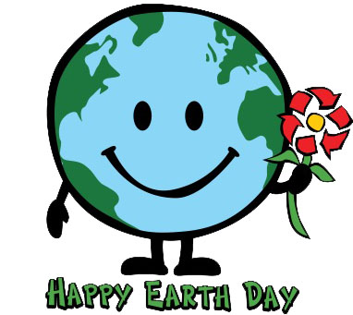

Practice your Two Times Tables (remember…it’s just like adding doubles!)
2 x 0 = 0
2 x 1 = 2
2 x 2 = 4
2 x 3 = 6
2 x 4 = 8
2 x 5 = 10
2 x 6 = 12
2 x 7 = 14
2 x 8 = 16
2 x 9 = 18
2 x 10 = 20

I’ve attached this link to a silly little song that might help: https://www.youtube.com/watch?v=D_uXcTsdGIw
Also , check out https://www.multiplication.com/games/all-games and www.splashmath.com for lots of great Math games.
I hope you have all tried logging on to Dreambox.com for some great Math activities.

