Howdy Canada!

We have been waiting to be your pen pals since Kindergarten and First Grade!

We live in a big city called Dallas in Texas. Our school is St. John’s Episcopal School. We have 18 people in our class. Our names are David, Lily, Cameron, Kaci, Adam, Sydney, Hudson, Emma, Henry, Mary Isabel, Pierce, Yasmin, Miller, Kendall, Henry, Scarlett, Spenser, and Kihanna.

Our room number is room 110. We all have a classroom job and we have two pet guinea pigs, named Fuzz and Ranger.

We study math, science, social studies, language arts, and handwriting. We have a lot of fun and learn a lot in our enrichment classes. Our enrichment classes are: Spanish, music, choir, art, and P.E..
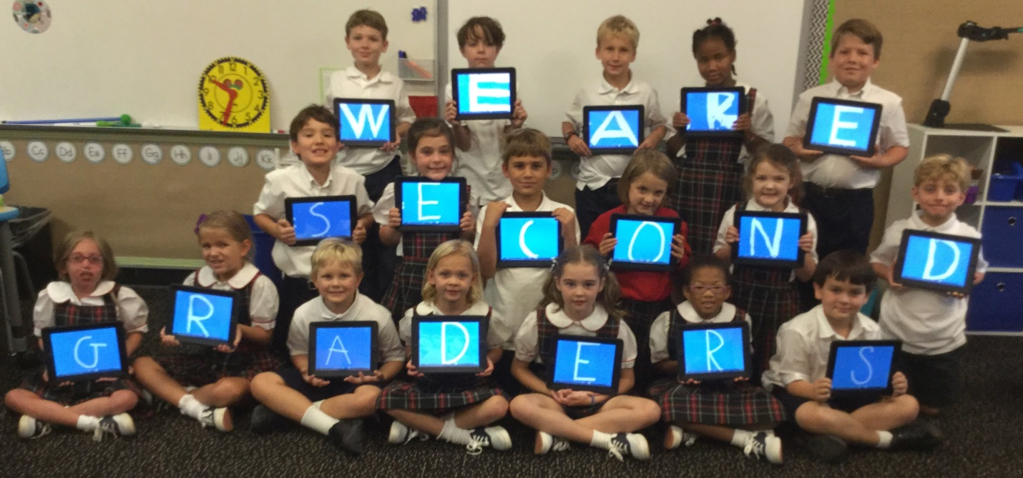
Our favorite sports are soccer, football, basketball, lacrosse, and fencing.

We are looking forward to meeting you this week!

Your friends,
Mrs. Booth’s Class

