Day 1 Calculator

Selected Response

Constructed Response

Selected Response

Shade in your choice on the bubble sheet. Do any required work in the test booklet.

1. What is the value of “**P**” in this equation?

5P + 8 = 63

1. 9
2. 11
3. 22
4. 50
5. The area of a triangle is 36 square centimetres. Its base is 6 cm. What is its height?
6. 6 cm
7. 8 cm
8. 12 cm
9. 16 cm
10. What is the probability, in percent, of rolling a 1, 2, 3 or 4 on a six-sided number cube?
11. 
12. 
13. 
14. 
15. 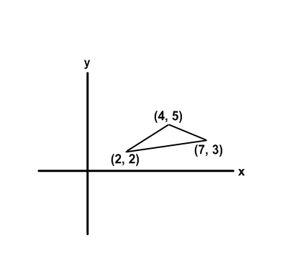A triangle is drawn in the first quadrant of a grid as shown. If it is reflected in the horizontal axis, the coordinates of the reflection would be:
16. (-2, -2), (-4, 5), (-7, -3)
17. (2, 2), (5, 4), (3, 7)
18. (-2, 2), (-4, 5), (-7, -3)
19. (2, -2), (4, -5), (7, -3)
20. Which calculation would solve this problem?

To make a flag, Jeff needs 1.2 m of material. His mother bought 10 m of material. How many flags can he make?

1. 10 + 1.2
2. 10 – 1.2
3. 10 x 1.2
4. 10 ÷ 1.2
5. Here is a set of data: 41, 39, 36, 44, 43, 24

Find the median without the outlier.

1. 41
2. 40
3. 39
4. 20
5. 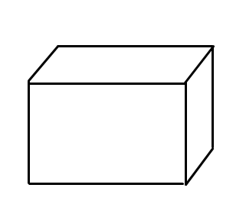How many pairs of parallel line segments are in this diagram?
6. 3
7. 6
8. 8
9. 9
10. A game involves spinning this spinner.

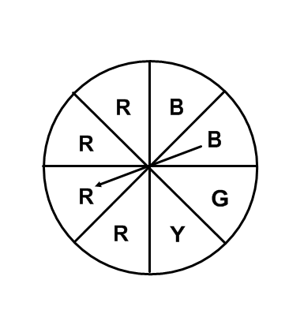 What is the probability of the pointer landing on R?

(a) 

(b) 

(c) 

(d) 

1. 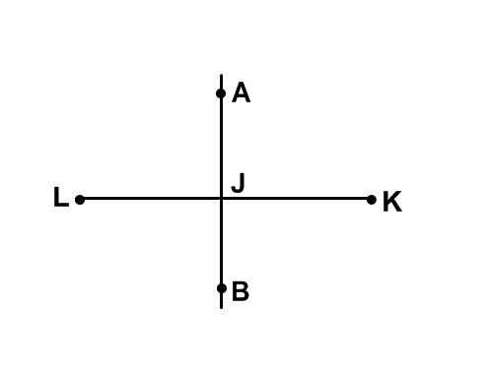 Line segment AB is the perpendicular bisector of line segment KL. Which statement is true?

(a) A is the midpoint of KL

1. AJ = BJ
2. JL = JK
3. LAJ is a right angle
4. Translate point C(0, 5) 3 units left and 1 unit down.

Write a rule to describe the translation.

What are the coordinates of the image point C´?

1. (x, y)  (x – 3, y – 1); (-3, 4)
2. (x, y)  (x + 3, y – 1); (3, 4)
3. (x, y)  (x + 3, y + 1); (3, 6)
4. (x, y)  (x – 3, y + 1); (-3, 6)
5. What is the least digit you would add to 873 to make the

number divisible by 10?

1. 2
2. 3
3. 5
4. 7
5. Copy and complete. (+6) - = -19
6. -13
7. 25
8. -25
9. 13
10. Each term of a number pattern is represented by 6n + 3, where

n represents the term number. What is the term number for a

term value of 69?

1. 66
2. 60
3. 12
4. 11
5. This tile represents x.

This tile represents +1.

Identify the tiles that model 3x + 6.

5. Jay was absent for a math test.

The test scores of his classmates were:

81, 90, 72, 95, 77, 50, 74, 83, 62, 86, 82, 55, 50, 52

Jay took a makeup test. What was Jay’s score if the class mean was 71?

1. 58
2. 56

(c) 55

1. 54

Constructed Response

1. At the trials for your school’s swim relay team, 5 swimmers recorded the times below.

|  |  |
| --- | --- |
| **Name** | **Time (s)** |
| Blake | 25.33 |
| Roger | 26.04 |
| Kyle | 27.15 |
| Tom | 26.67 |
| Glen | 25.57 |

1. Which four swimmers would you select for the relay team? Explain.
2. How fast would you expect the team to swim? How did you arrive at your time?
3. A team from another school had a trial time of 1 minute 38 seconds. Will they beat your school?

Day 2 Non-Calculator

Mental Math

Selected Response

Constructed Response

Solve the following questions using mental math.

Show your thinking and solve the problem.

1. 15% of 180
2. 2.5 x 14

(C) 700 – 396

Selected Response

Shade in your choice on the bubble sheet. Do any required work in the booklet.

16. Which of the following is arranged from least to greatest?

(a) 

(b) 

(c) 

(d) 

17. Add 0.769 + 24.3 + 5.8

1. 1.0889
2. 30.869
3. 108.89
4. 1.07

18. Which number is divisible by 4 **and** 5?

(a) 210

(b) 315

(c) 420

1. 630

19. If a bag contains 100 red cubes, 50 blue cubes, 25 yellow cubes, and

1. green cubes, what is the probability of Alicia choosing a blue cube?

(a) 

(b) 

(c) 

(d) 

20. Which ordered pair below would be found in the table of values for the

equation y = 2x + 3?

(a) (6, 15)

1. (15, 6)
2. (11, 8)
3. (8, 11)

Constructed Response

II. Cathy babysits for her neighbors, the Parkers, on the weekend. She

charges $8.00 per hour plus a $5.00 flat rate because she always

gets her own ride to and from the house .

1. Write an equation that Cathy could use to determine her pay.
2. If Cathy made $53.00 on Saturday night, how many hours did she work?
3. Cathy is thinking about increasing her flat rate to $10.00, but dropping her hourly charge to $6.00 per hour. Is this a wise choice? Support your answer using numbers, pictures or words.