Everyone at their best:

**FRENCH LANGUAGE LEARNING IN NEW BRUNSWICK**

**2025**

##### **HOW MUCH TIME IS SPENT IN FRENCH LANGUAGE INSTRUCTION?**

##### **IS THE PROGRAM OFFERED IN ALL SCHOOLS?**

**WHAT IS TAUGHT IN FRENCH?**

## ENGLISH PRIME

Learners have French instruction as part of their

overall curricula.

**Grades K to 3:** % of time and grade level will vary by schoo**l**

**Grade 4:** 9% of time

**Grade 5:** 60% for 5 months and

9% for 5 months

**Grade 6 to 8:** 12% of time

**Grade 9:** 10% for the year

**Grades 10-12:** Grade 10 is a graduation requirement.

Learners are encouraged to take 3 or more courses in French Grades 10 to 12.

Yes

French is taught through the literacy-based neurolinguistic and action-oriented approaches.

Early and continuous exposure to the French language and culture fosters appreciation and a desire to excel.

Schools offer intensive French in Grade 5 as part of the program. This may vary in your learner’s school. Please contact your school’s administrator.

## FRENCH IMMERSION

**(GRADE 1 ENTRY)**

**Grades 1-2:** 85% **or more of the school day**

**Grades 3-5:** 80%

**Grades 6-8: Equivalent to** 70%

**Grade 9:** 50%

**Grades 10-12: Equivalent to** 10 courses in French

Most aspects of learning occur through French, the language of instruction. Learners acquire the

No language through language

arts and through other subjects which are taught in the French language.



**Grades 6-8: Equivalent to** 70%

**Grade 9:** 50% **of the school year Grades 10-12:** Equivalent to 10 courses in French

No

Most aspects of learning occur through French, the language of instruction. Learners acquire the language through language arts and through other subjects which are taught in the French language.

**LATE FRENCH IMMERSION (GRADE 6 ENTRY)**

The later entry point for the French Immersion program

**HIGH SCHOOL ONLINE COURSES**

There are a number of FSL courses in Grades 10 to 12 including online options such as: Post-Intensive French 110 and 120, Techniques de communication orale 120, Co-op Education, Intro to Environmental Science, Hospitality and Tourism, Law, and Writing. English Prime learners who are deemed to be at the intermediate level by school personnel may attempt any French course.

# Frequently Asked Questions

### **WHAT IF PARENTS CANNOT SPEAK FRENCH?**

There is no expectation that families of learners in any of the program options must be able to speak French. All program options are designed for children whose first language is not French.

### **HOW CAN I HELP MY CHILD?**

You can read to your child at a young age. This strengthens literacy skills for first and additional language learning. Additionally, family members can help by communicating regularly with their child’s educators. It

is also valuable for families to encourage their child to read and write in both English and French and to listen to French music, radio or television. Families selecting French

Immersion ensure the most benefits from this program by exposing their learners to French beyond the school experience. FLORA is an excellent resource to foster continued learner engagement for all students.

[HTTPS://FLORA.NBED.NB.CA/INDEX.HTML](https://flora.nbed.nb.ca/INDEX.HTML)

### **WHAT IF MY CHILD NEEDS SUPPPORT?**

French and English are the Official Languages of Canada and New Brunswick. All learners in the anglophone sector have the opportunity to learn French. All programs can meet the needs of learners. There are a variety of

ways to support student success in French second language. This can include the use of a Personalized Learning Plan, curricular adjustments, accommodations, universal learning supports as well as strong and inclusive classroom practices.

### **WILL MY CHILD LEARN THE SAME THINGS AS CHILDREN IN ENGLISH CLASSES?**

The curriculum follows the guidelines of the NB Department of Education and Early Childhood Development. Learners work towards the same goals for all subjects

regardless of language of instruction; however, instructional time is dedicated to acquiring the vocabulary terms necessary for the learning area.

# Oral Proficiency Levels

**New Brunswick Oral Proficiency Scale/Common European Framework of Reference**

**ATTITUDE AND MOTIVATION CONTRIBUTE TO SUCCESS IN ATTAINING LANGUAGE TARGETS. READING AND WRITING IN FRENCH REINFORCES AND IMPROVES ORAL LANGUAGE SKILLS**

## INTERMEDIATE~B1.1

#### TARGET FOR GRADE 12 INTENSIVE FRENCH LEARNERS

The learner is able to satisfy routine social demands and limited requirements in school/work settings with a speaking vocabulary sufficient for simple conversation, with some paraphrasing.

**The learner can:**

* provide information and give explanations with some degree of accuracy;
* handle most common social situations, including introductions and casual conversations about events in school and community;
* provide autobiographical information in some detail;
* give directions from one place to another; and
* give accurate instructions in a field of personal expertise.

## INTERMEDIATE PLUS~B1.2

#### TARGET FOR GRADE 12 LATE FRENCH IMMERSION LEARNERS

The learner is able to satisfy the requirements of a broad variety

of everyday, school and work situations, often showing a significant degree of fluency and ease in speaking.

**The learner can:**

* discuss concrete topics relating to special fields of competence as well as

subjects of current public interest;

* start, maintain, and end simple face-to-face conversations about familiar topics or personal interests; and
* compare and give opinions in a conversation.

## ADVANCED~B2.1

#### TARGET FOR GRADE 12 EARLY FRENCH IMMERSION LEARNERS

The learner is able to speak the language fluently with good control of grammar and with sufficient structural accuracy and vocabulary to participate effectively in most formal, and in all informal, conversations on practical, social, and academic or work-related topics.

**The learner can:**

* describe in detail and narrate accurately;
* discuss abstract topics and ideas as well as events; and
* support opinions and hypothesize.



**PLEASE NOTE:** The Innovation Network is a group of schools across the province working within the human-centered design process to focus on French Language Learning. Any changes to programming will be communicated by school administration.

The level of French that learners attain by high school graduation will vary from one student to another, in the same way as performance varies in other areas.

**Time spent learning and interacting in**

**Time spent learning and interacting In French will impact the level of proficiency achieved**

**Superior**

**Advanced Plus Advanced**

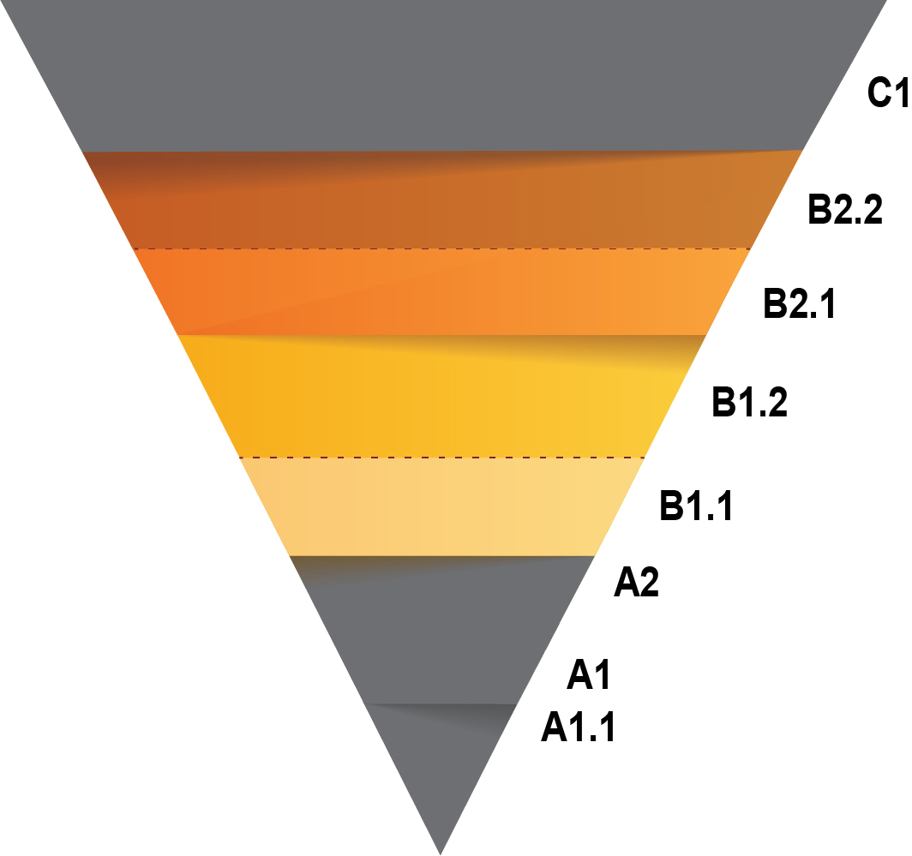

**Intermediate Plus Intermediate**

**C1 B2.2**

**B2.1**

**B1.2**

**B1.1**

**A2**

**French will impact the level of** proficiency achieved



New Brunswick Oral

Proficiency Scale

**Basic**

**Novice**

**A1**

**A1.1**

Common European Framework of Reference Scale