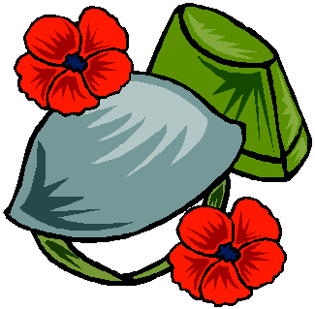

Remembrance Day



We will remember and give thanks!

We are thankful to the brave men and women who saved our country, Canada. Because of them we live in peace and are free to enjoy many wonderful things. Draw a picture, to say thank you!