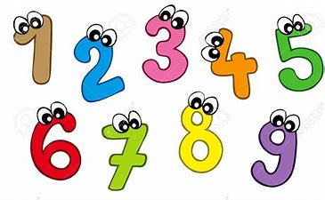
Homework
October 12th, 2022
Dear Parents/Guardians,
Math games and supplies were sent home today. I would ask that the students play one math game per night (Monday- Thursday).
Supplies
Each student was sent home with the following:
- Dice (2)
- Dry erase marker (2)
- Plastic sleeve
- 8 math games
Math Games:
- Cover That Number
- Before and After
- Race to the Top!
- Roll and Cover (3 variations)
- One less
- One more
Game Directions
- Roll and Cover Games: Roll a dice and colour in that corresponding number. The winner is the last person to cover the final number. To make more challenging, colour the number that is one more/one less than the number that was shown on the dice. These can be played with a partner.
- Race to the Top!: Roll a dice, write down the number in the appropriate column. The winner is the first person to write the final (top) number in a column. Can be played with a partner.
- Before and After: Roll a dice, write the corresponding number in the ‘my number’ column, then write the number that comes before and the number that comes after in the appropriate columns. Can be played with a partner, one person rolls, fills in the chart, then the other player does the same.
- One more & One less: Please follow game directions on the sheet.
- Cover That Number: Please follow game directions on the sheet.

The math games are double sided. To play, please place the chosen game in the plastic sleeve and use the dry erase markers to colour in the answer. This allows the games to be played multiple times. It does not hurt to play a game more than once. Math games will be updated in relation to what we are learning in class, new ones will be sent home periodically.

Please continue to read a levelled book each night (Monday-Thursday) as well and practice sight words or letters and sounds (whatever has been sent home). Make sure to log the levelled book that the students are reading each day.
It is fine to keep the homework folder and levelled books home during the week. I would ask that the levelled books are returned on Fridays, to allow us to change them out for the following week. 😊 When the student can read their sight words quickly, please send the signed sheet back. When the students are practicing their letters and sounds, please use their finger to trace the letters. Make sure to follow the arrows!
Please make sure that the student’s agenda and note folder (bring back/take home) is sent to school daily. This is the main form of communication between school and home.

Reminder: the homework that is being assigned is important to complete daily as it will help reinforce the student’s skills with what they are learning each day. It is not intended to take long. If issues arise or they are having trouble with any of the assigned work, please let me know. I am here to help! Thank you! Have fun playing!

