MEMO
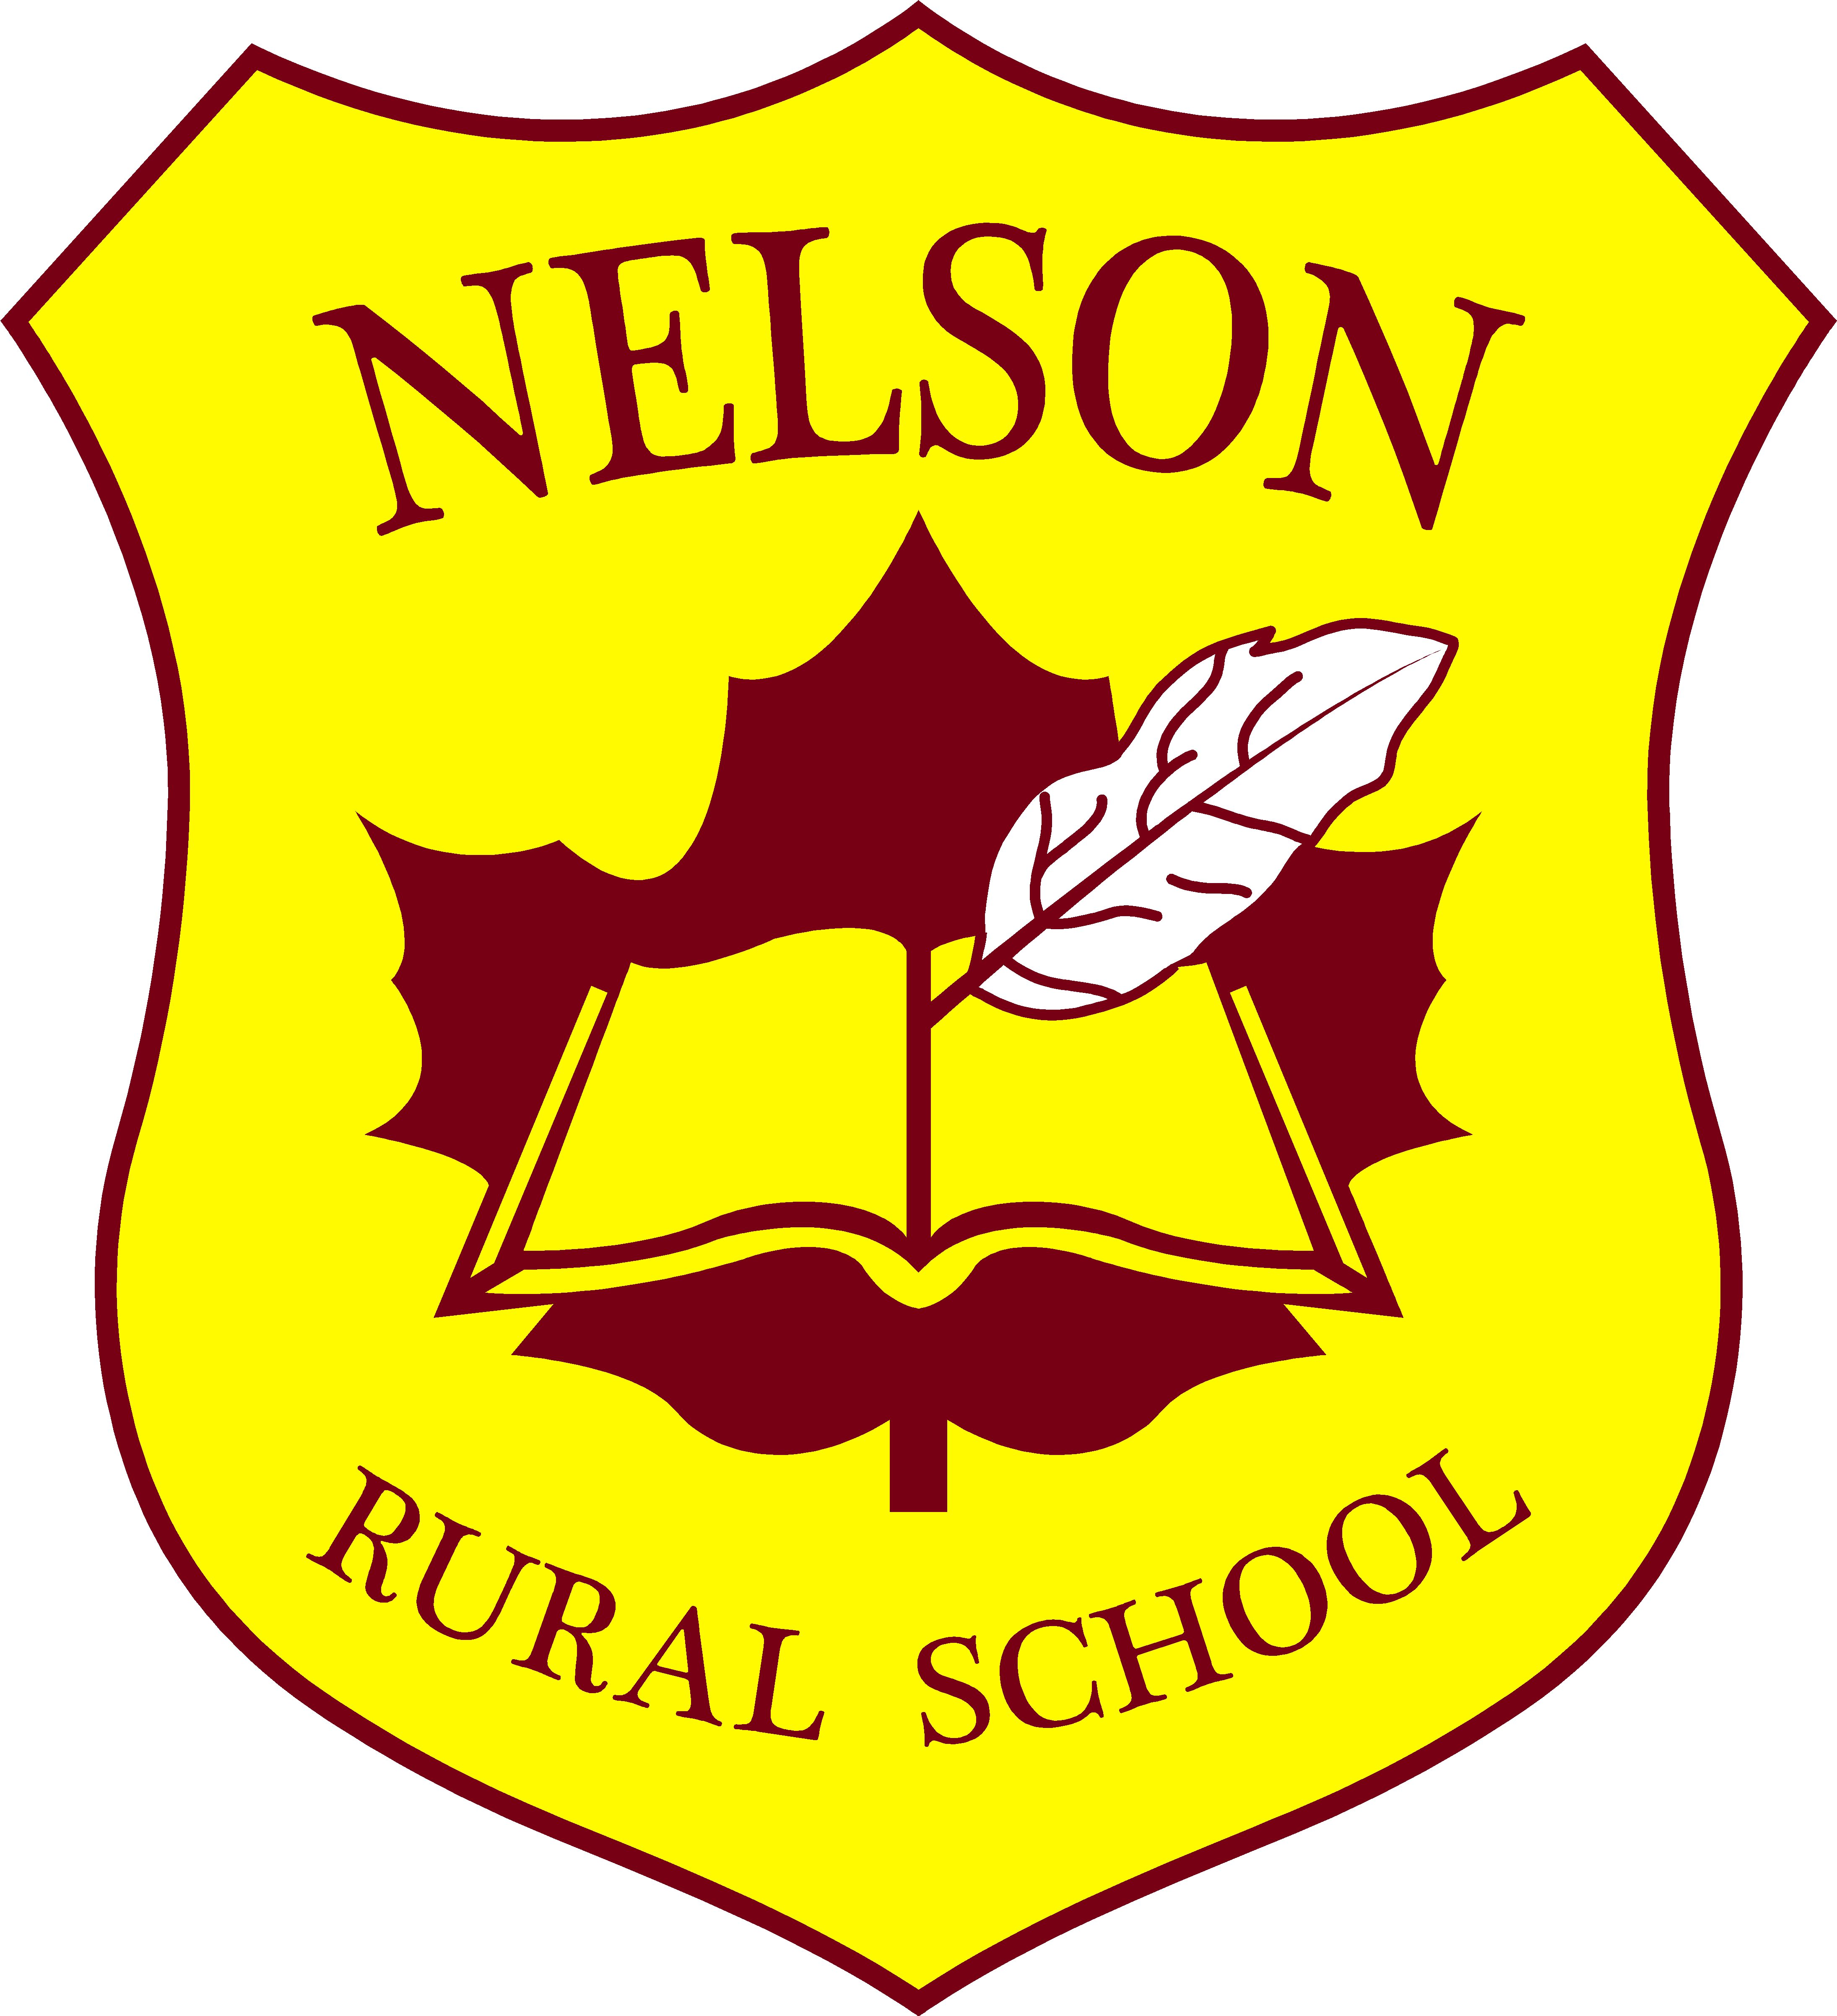
To: Parents/Guardians
Fr: Ms. Sullivan
Re: Home Learning Kits
Date: September 14, 2021

We have been asked to put together a Home Learning Kit to use if schools are shut down.

Please note that these will be in the students’ book bags today. The kits are only to be used if schools are closed, and we have to go to Home Learning/On-Line Learning.

The kits will be in a zippered bag. Please keep them in your child’s book bags until needed. Do not take them out and leave at home. That way we can add to them or take things out that are not needed.

The materials in the kit will be used with plans and other learning materials that will be added to the class page on the school site when needed.

We will ask that the kits be returned at the end of the school year.

I appreciate your assistance with this matter. It is our hope that we will not need to use them, but with the Covid-19 protocols, we never know when a shutdown may happen.

