Go Raiders

Hey everyone! I hope all my students will be keeping active over the next little bit until we return to Nelson Rural. I just wanted to let everyone know that each week I will be putting various challenges on my teacher page. My hope is that students give the challenges a try in order to stay active. It is important for our overall well-being both physically and mentally that we do physical activity for at least 30 minutes a day.
For myself personally I've will be keeping it very simple by going for an hour long walk with my dog Mason or my family each day. Also doing yard work like raking leaves is another simple and easy activity that can be done at any age.
If you find yourself at a loss of what to do you can always use some of the links that I have put up on my page. My personal favourite is the Body Coach who does a daily 30-minute workout which can really push you.
I would love you to send me a few photos and videos through email of students being active and helping out around the house so please send them to Carla.dickson@nbed.nb.ca
If you have any questions about the challenges or physical education in general, please do not hesitate to email me!

Thanks, and hopefully we will be back together real soon! Go Raiders!!

Love,
Mrs. Dickson

Websites to Visit for Activities of Phys. Ed

- PE With Joe | Wednesday 22nd April - YouTube – He has many workouts you can choose any that you like and its only 30 minutes!

2.WATER BOTTLE BOWLING
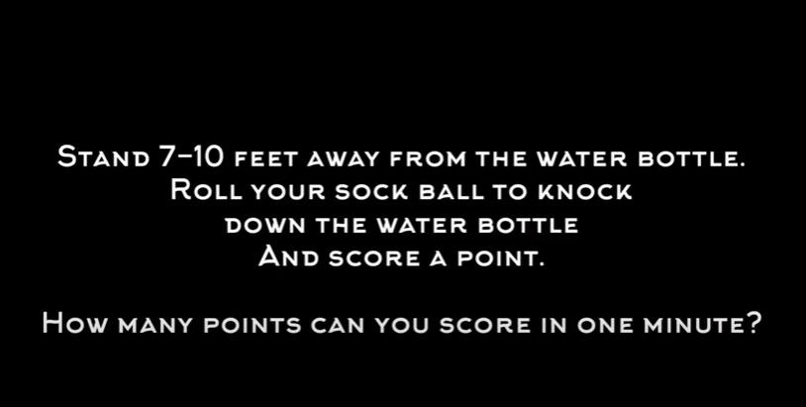
PE at Home: Water Bottle Bowling - YouTube- We have worked on UNDERHAND ROLLING this is a great way to practice it! Let me know what your best score was for the week!

3.PANCAKE FLIPPER
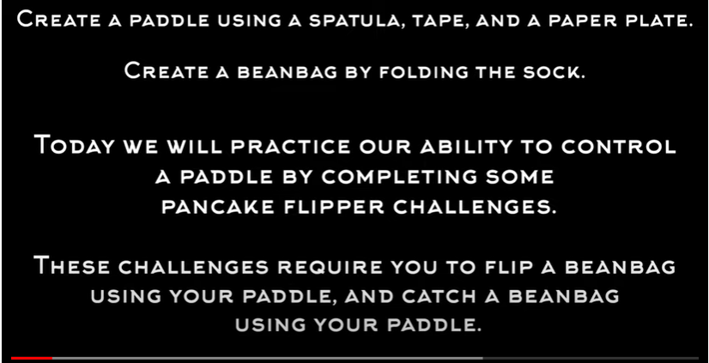
PE at Home: Pancake Flipper from OPEN Physed - YouTube – This is the other skill we worked on for a while now – CATCHING.

4.TARGET PRACTICE
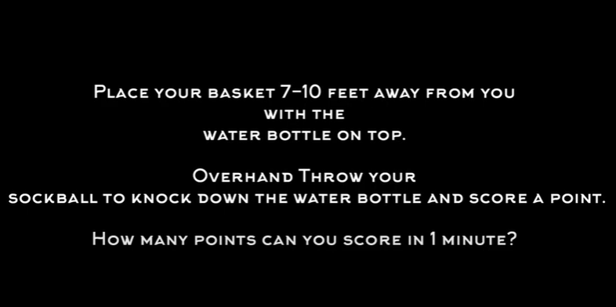
PE at Home: Target Practice (Overhand Throwing) - YouTube – We have been using our Halloween ghosts, pumpkins, bats, and black cats at targets for the last few weeks. Now that you are at home try out this target practice game to help with OVERHAND THROWING.

