The Letter **Dd**

Name:_____________

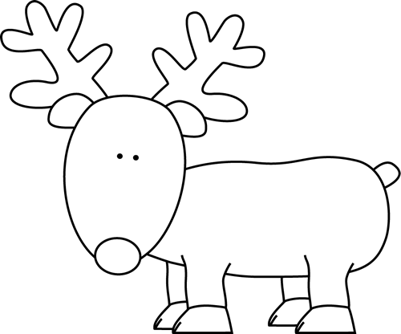

I see a deer.

[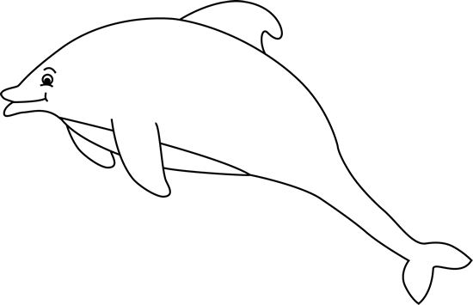](https://www.mycutegraphics.com/graphics/sea/black-white-dolphin.html)

I see a dolphin.



I see a donut.



I see a dog.

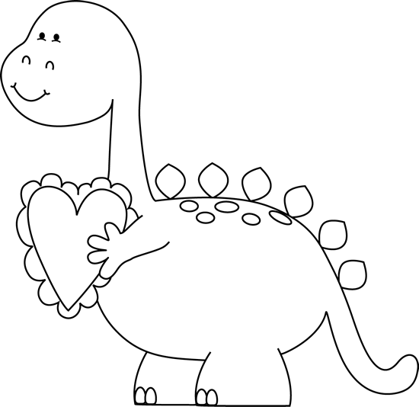

I see a dinosaur.

I see a door.

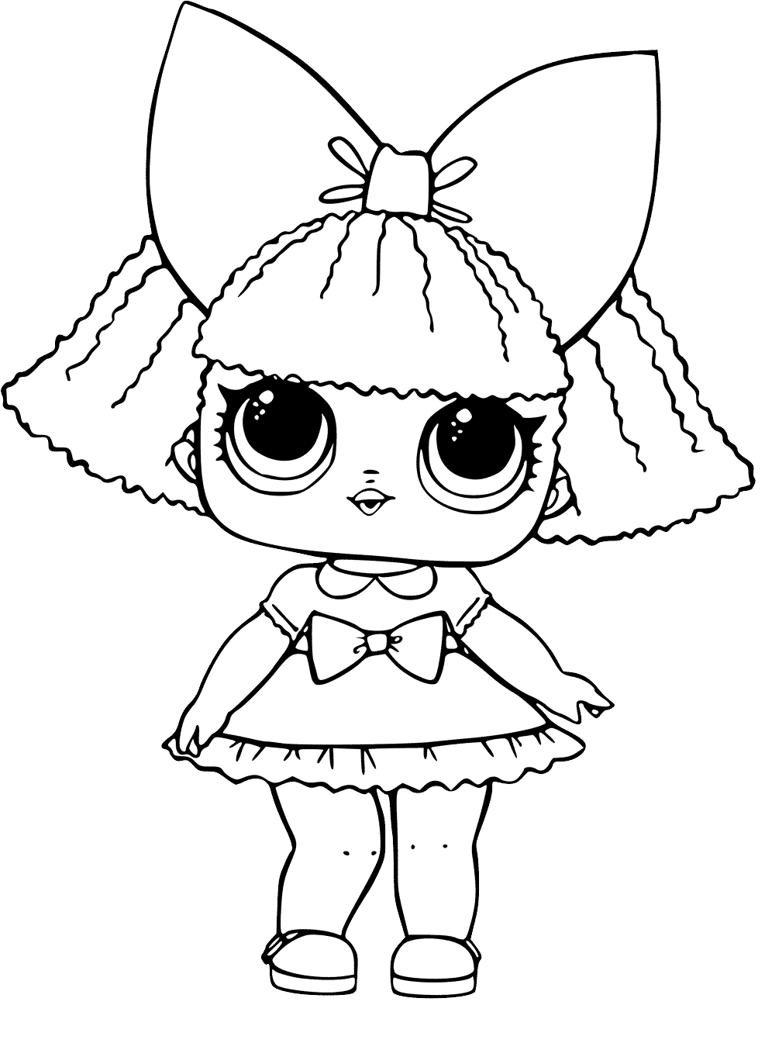

I see a doll.