Warm up Activity: Good Noodle Dance – The Little Green Froggy 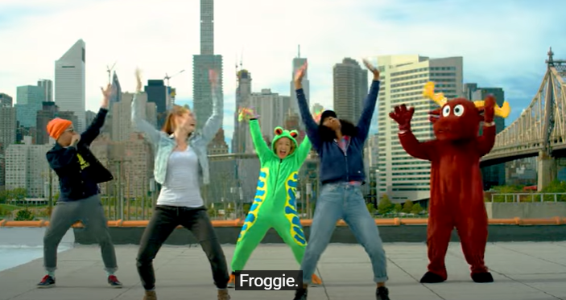
The Little Green Froggy | Songs For Kids | Dance Along | GoNoodle - YouTube

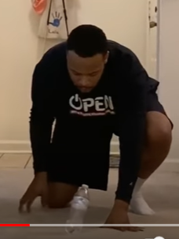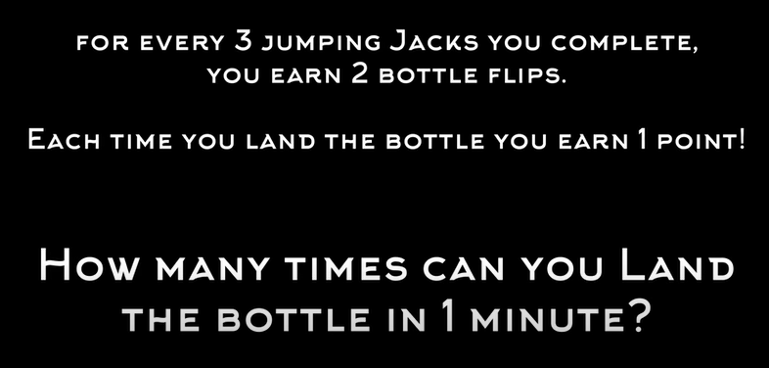

PE at Home: Bottle Flip Chaos - YouTube – This can be done all week long. Record your record each time you do it and let me know what your best score is at the end of the week. Email me a video or just a quick note to tell me your score. Maybe even get your family involved and see who the CHAMPION at your house is.

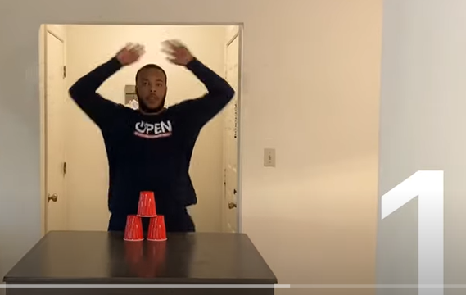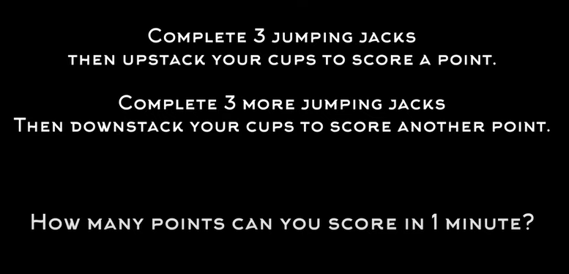
PE at Home: Stacks & Jacks- 3 Stack Challenge - YouTube – If you liked the Bottle Flip challenge this one is fun too! Give it a try!

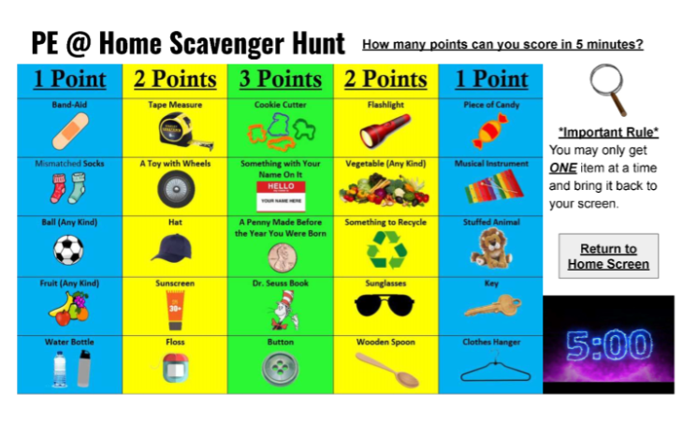
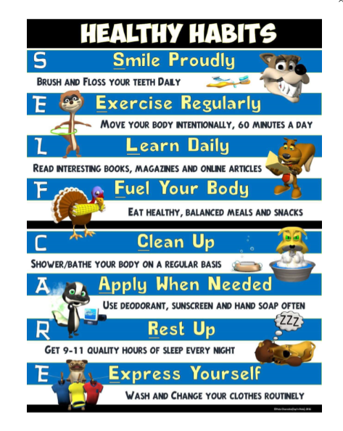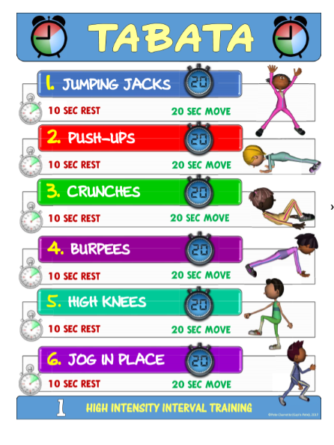
The activities listed above are fitness related activities and a scavenger hunt you can try to stay active. I also provided a sheet with Healthy Habit suggestions to help you live a healthier and more active life. Students can create a scavenger hunt of their own if they wish.

Remember to always get your heart pumping as it is a sign that you are working hard and becoming healthy! Good luck with this week’s challenges and activities and I hope to see you all back at school real soon. Take good care of yourself - GO RAIDERS!!!!!

