Animals

I can see the zebra.

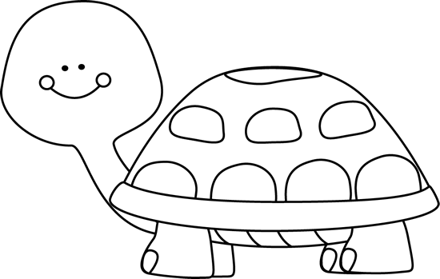

I can see the turtle.

I can see the horse.

I can see the elephant.

I can see the cat.

I can see the fish.

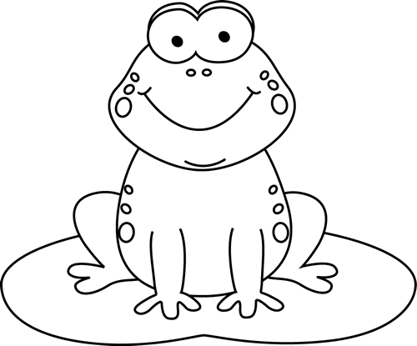

I can see the frog.