Thursday Home Learning Schedule
Morning Meeting
- Listen to and sing Bonjour, Bonjour!

- Click on and watch this video Comment ça va? Les sentiments!

- Listen to and sing French Alphabet RAP and L'alphabet en Français

- Listen to and sing Les jours de la semaine and Les mois de l'année

- Listen to the story about Lucie Tortue

- Listen to, sing, and do the action for our sound of the week Chanson - Lucie Tortue

- Your child can continue working on their message of the week (click here #Message). This usually takes us the entire week to complete. We read and reread the message all week long. Then, each day, we focus on one of the items below. If you child is finished, they can move on to the next subject activity in our schedule.
- Highlight the words of the week
- Highlight the words that contain the sound of the week (u)
- Print the words of the week
- Print three words that contain the sound of the week.

Les mots de la semaine (words of the week) :
fais, vais, vois, suis, donner

Literacy
Daily Five (cinq au quotidien) – Please ask your child to do five 10-minute rotations. That is, after 10 minutes of working on one activity, ask them to “rotate” and do the next activity for 10 minutes, and so on, and so on. We do this in class so they should understand.

- Word Work (études de mots): write the words of the week plus any five words from their lists (either in homework duotang or home-learning duotang) in a fun and fancy way (colourful, cursive, bubble or blocks letters);
- Read to Self (lecture à soi): login to Boukili and read or listen to books. Our class code is 80l3f9 (eight, zero, el, three, ef, nine) if needed;
- Writing (écriture): please ask your child to draw a picture and write a sentence to go with it. I would like them to write about what they like: “J’aime jouer dans les feuilles avec Alice, Oliver, Eloise et mon chien, Teddy”;
- Listening Center (centre d’écoute): ask your child to choose (scroll down) a video to from Mini TFO. IF the episode is longer than 10 minutes, they may listen until the end, or stop after 10 minutes (up to you!);
- Game (jeu): login to Boom Cards using their NEW password. Please let me know if you did not receive a message from me yesterday containing your child’s new password.

Recess: wash hands, eat a healthy snack, and play outside for 20 minutes

Math
Warm-up: Listen to and do the actions Chanson: Compter jusqu'à 100

Daily Four (quatre au quotidien) – Please ask your child to do four 15-minute rotations. That is, after 15 minutes of working on one activity, ask them to “rotate” and do the next activity for 15 minutes, and so on, and so on. We do this in class so they should understand.

- Zorbit’s: ask your child to login to Zorbit's Math Adventure. Please let me know if you did not receive a message from me yesterday containing your child’s login information. If you do not have access to Zorbit’s at home, please ask your child to try choosing a game from Cool Math Games;
- Number of the day worksheet (nombre du jour): Choose the next number of the day worksheet from your child’s home-learning packet;
- Game (jeu): play a card game or board game with you, a sibling or friend;
- Skip Counting: Ask your child to fill in the missing numbers in grids like the ones below. Challenge your child. Ask them to make a grid with missing number for you to complete.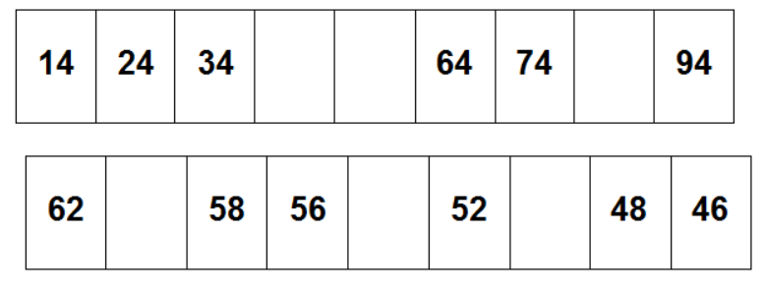
Lunch: wash hands and eat a healthy lunch
Gym
Free time inside or outside.
Art
I found this and thought the kiddos might enjoy it
How to Draw Éléphant et Rosie

Message de la semaine
Les mots de la semaine : fais, vais, vois, suis, donner
Son de la semaine : « u »

Bonjour les amis !

Le dimanche, je suis allée chercher des bonbons avec mes enfants pour l'halloween. Ils ont reçu beaucoup. Je pense qu'ils peuvent donner quelques bonbons à son papa et moi. Chaque automne, je regarde par la fenêtre et je vois des feuilles toutes en couleur. De plus, je fais des bricolages avec des feuilles. Peut-être, après avoir mangé le dîner, je vais aller conduire ma voiture près de la forêt pour faire une marche avec ma famille et là on va ramasser beaucoup de feuilles pour faire des bricolages ensemble.

Écrits les cinq mots de la semaine :

- ______________________
- ______________________
- ______________________
- ______________________
- ______________________
Trouve et écrits trois mots qui fait le son de la semaine (u) :

- ____________________
- ____________________
- ____________________

