Gg is for……

Look! We can see the gorilla.

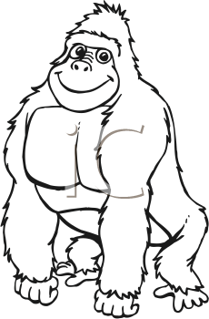

Look! We can see the girl.

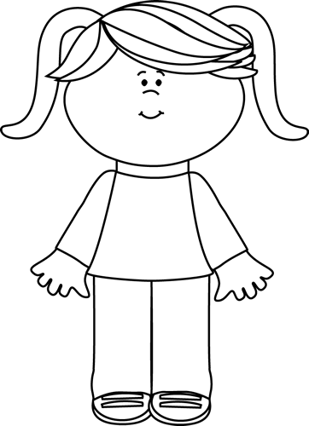

Look! We can see the goats.

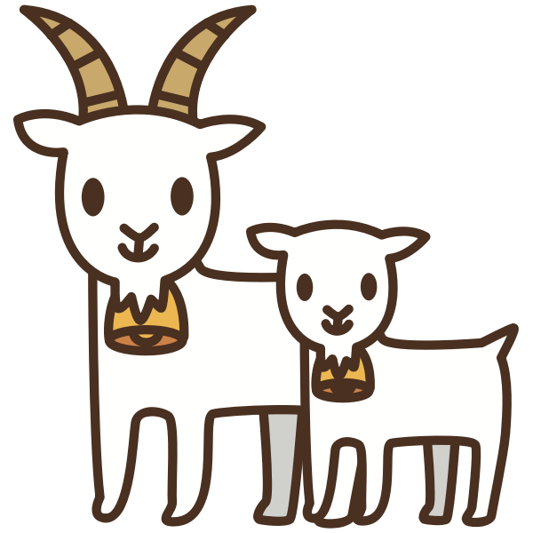

Look! We can see the gloves.

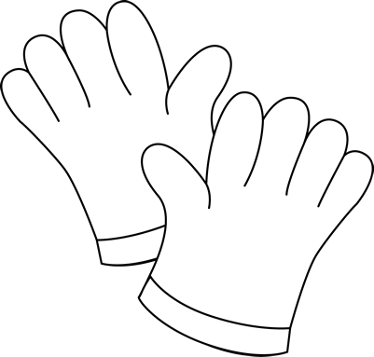

Look! We can see the ghost.

Look! We can see the grapes.

Look! We can see the guitar.

