Free Math Apps
***Descriptions are from App Store
1. Pet Bingo
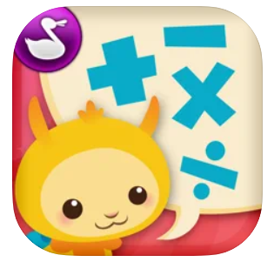
Pet Bingo takes kids on a mathematical adventure! Through fun multi-level activities, kids will learn math FUN-damentals like addition, subtraction, and multiplication!

2. Sushi Monsters
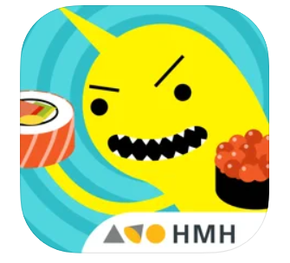
Meet Sushi Monster! A game to practice, reinforce, and extend math fact fluency is completely engaging and appropriately challenging.

Strengthen reasoning strategies for whole number addition and multiplication by helping monsters make a target sum or product. Earn points with each correct answer… but watch out for distractions! To be successful, plan ahead and strategically select numbers from the sushi counter.

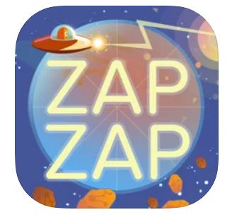
3. Zap Zap Fractions
Zap Zap Fractions is the most fun and simple way to learn the basics of fractions – complemented by the perfect balance of gamification.

