Ff is for……

Here is the fish. I can see it.

Here is the frog. I can see it.

Here is the fork. I can see it.

Here is the French fry. I can see it.

Here is the feather. I can see it.



Here is the football. I can see it.

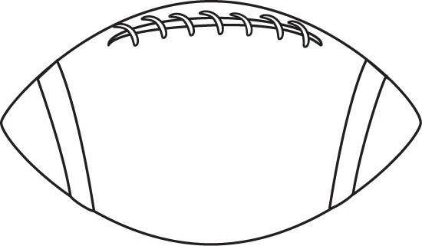

Here is the flower. I can see it.

