Ee is for……

Look at the elephant. It is here.

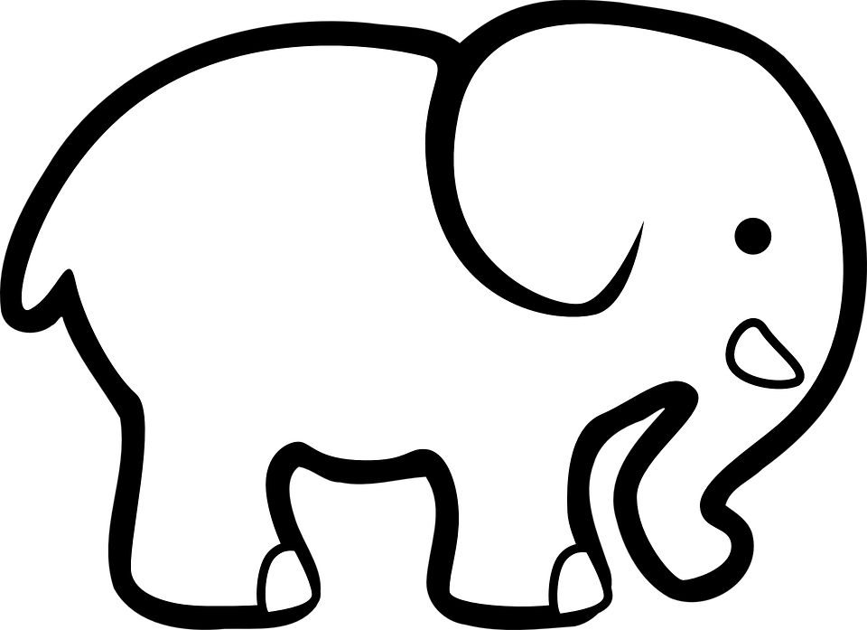

Look at the eagle. It is here.
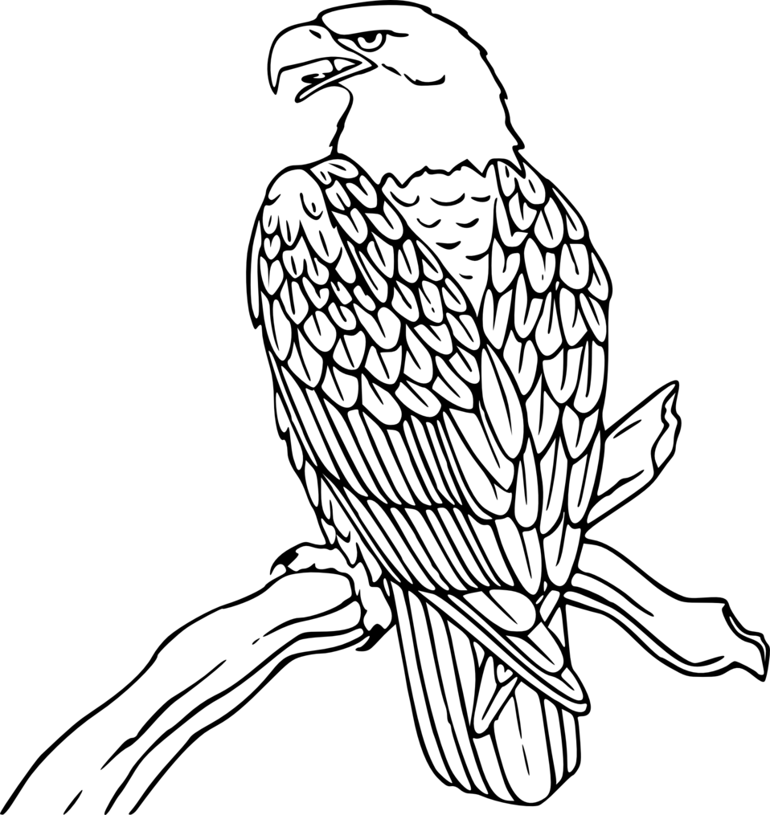

Look at the egg. It is here.
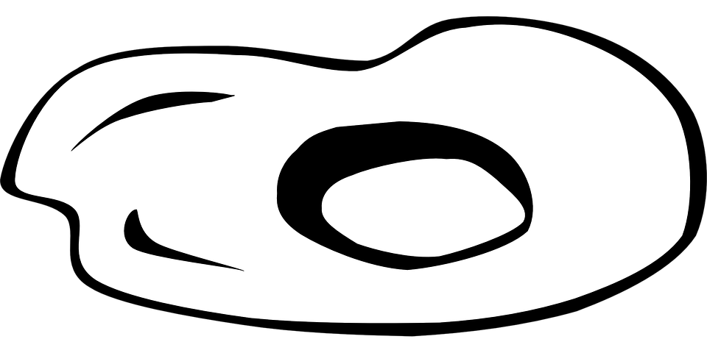

Look at the Easter Bunny. It is here.
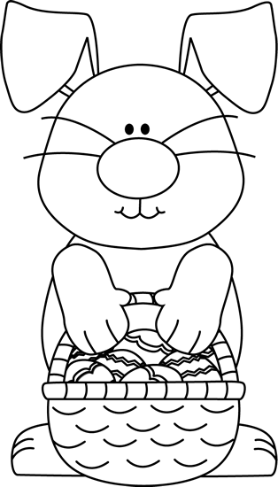

Look at the elf.It is here.
