Grade ¾FI Walsh: Home Learning Week #5
May 4th-May 8th

Literacy (French Language Arts)
(50 minutes)
Reading  (20 minutes) | Oral Language Communication  (20 minutes) |  | Writing  (10 minutes)
The following websites include various reading activities:  - Raz-Kids  Students should read (practice) their assigned book every day and on Friday do the quiz. If they do the quiz prior to Friday, they will not have access to their book anymore.  https://www.raz-kids.com/  Teacher Username:  jennawalsh  Click on your name and your password is your LAST name  2. La souris-web suggest links to various reading sites (stories, tales, virtual books etc) to read or listen to. Students can use these sites as they please.  https://www.lasouris-web.org/primaire/francais-lecture.html  LALILO is site that offers phonics and reading lessons. Students are already registered. This is a new site, please take time to explore it!  BOUKILI  http://boukili.ca/en  This is a free App that has illustrated books in French. All you need to do is sign up!  https://student.lalilo.com/#/login  Code to login: HZJPKV  BOOM! is a site the students are familiar with. I will buy more decks in the coming weeks, so they will have something different to work on.  https://wow.boomlearning.com/  Username: mmewalsh  Password: Walsh | I encourage students to communicate with their classmates in French:  - via Kids Messenger (app)  - phone conversation  - prepare a video to share with the class (see below for weekly suggested video)  - teach parents and/or siblings some French  - They also can voice message me on Facebook Messenger whenever they would like and I will respond!  Week 5- Suggested Oral Language Activity:  Mon monstre  Students can draw a monster and then describe their monstre.  Ex: Voici mon monstre. Il s’appelle Larry. Il est gros et bleu. Il a les cheveux jaunes et un petit nez noir. Il a cinq bras et une jambe. Il aime manger du brocoli et des sardines. |  | - Write in a journal or email me about your day, how you are feeling or something interesting you might want to share.  - Send messages to classmates in French via Kids Messenger.  - Share your writing with your classmates or read your writing out loud and take a video to share with your classmates.  Week 5- Suggested Writing Prompt:  La Devinette (A Riddle)  This week is all about clues: “les indices”.  I am going to attach a Monster Sheet and the students can write their clues down and if they choose to send it to me, I can guess which Monster they are describing. I will also attach my example for the students to use as a model. I will underline the parts of the sentence they need to change to describe their monster.
Numeracy
(20 minutes)
High-tech |  | No-tech
For math, students will have the option to work on Splashmath (Splash Learn) and/or Dreambox.  SPLASHLEARN: www.splashlearn.com/login  Step 1: Select Class  Step 2: Enter class code: IOGUQE  Step 3: Select your name  Step 4: Enter Password  If your child forgot his/her password, please let me know and I will send it to you.  DREAMBOX: https://play.dreambox.com/login/knjs/8s78  DREAMBOX NOTES: To log in you must use the provided link or it will not work. You can log in via the class code (93137) or the login credentials provided to you. |  | The following are no-tech math activities that can be done around the house without the use of technology. They can be fun for the whole family!  - Card Games: War, Crazy 8s, Go Fish, Uno, Rummy, Crib, etc.  - Board Games: Monopoly, Checkers, Chess, Yahtzee, Snakes and Ladders etc.  - Cooking: Follow recipes to work on fractions and measurement.  - Data Analysis: Make simple graphs representing data overtime (such as daily weather, gas prices, etc).  - Estimation: Estimate the cost of your grocery bill, time it takes to do a task, measures of lengths and distances  - Telling time: Practice using digital and analogue clocks.
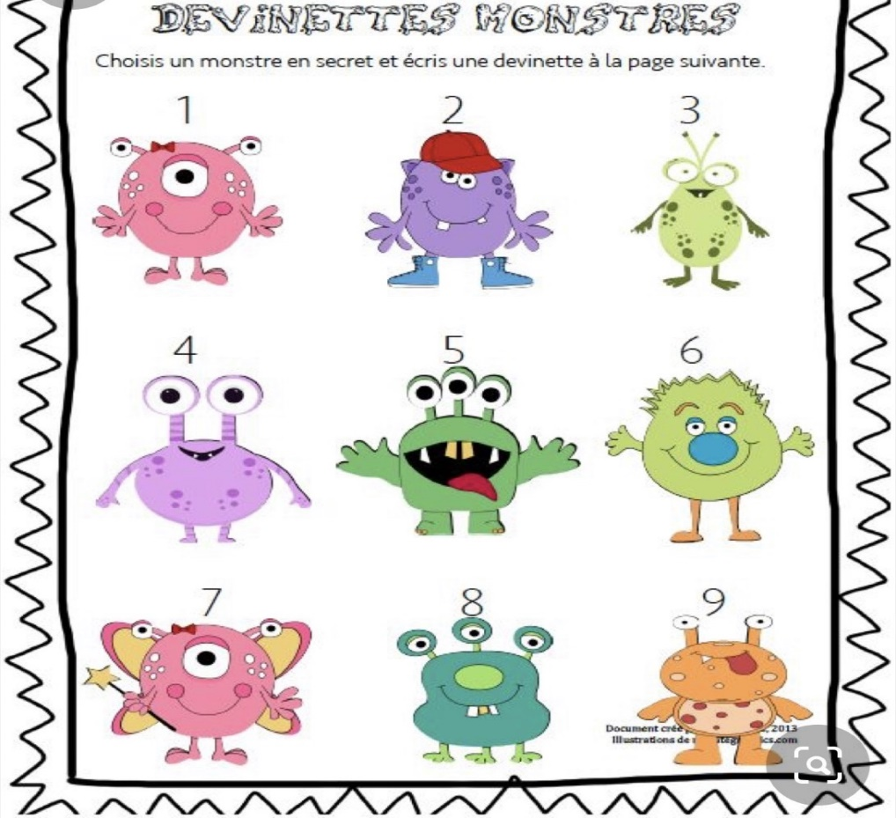
Indices:
1. Le monstre que j'ai choisi a trois yeux.
2. Le monstre que j'ai choisi a deux jambes.
3. Le monstre que j'ai choisi est rose.
4. Le monstre que j'ai choisi a des taches blanches.
5. Le monstre que j'ai choisi a deux bras.

