Math 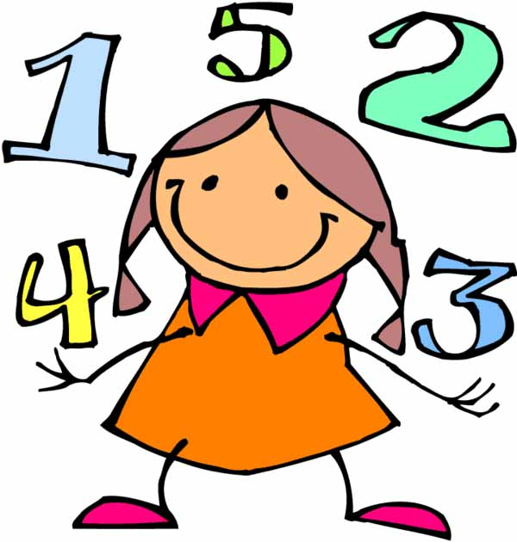
Dear Families,

This upcoming unit will focus on deepening your child’s understanding of number relationships, counting and place value.

The learning outcomes for this unit are:
- Read numbers to 100 in symbols and in words
- Build numbers to 100 with concrete materials.
- Estimate the number of objects in groups to 100
- Count forward and backward using different tools such as objects, a number line, a 100-chart and coins.
- Show numbers to 100 as tens and ones using a variety of materials
- Compare and order numbers to 100
- Demonstrate if a number ( up to 100) is odd or even
- Describe order or relative position using ordinal numbers (up to 10th)o

