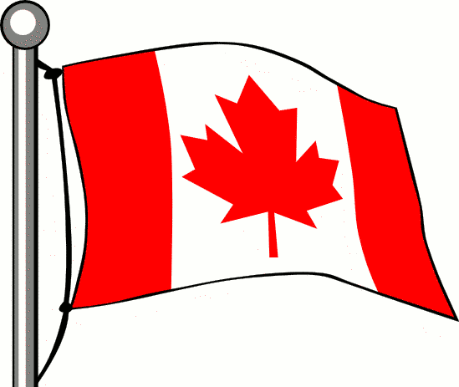 Happy Thanksgiving
From 2nd Grade at Nelson Rural School
Miramichi, New Brunswick, Canada
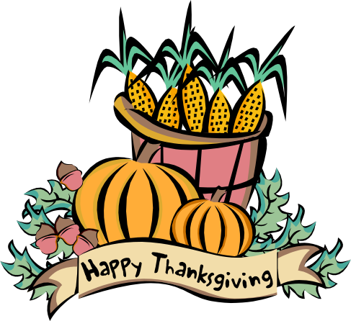
Thanksgiving in Canada is on the second Monday in October. This year the date was on Oct 14th, 2013. Thanksgiving is a time to spend with your family and friends and to give thanks for the wonderful food we had all year long.
Also, we are thankful for our warm house, our healthy planet, our healthy bodies and our happy families. Each of us celebrates this special holiday a little bit different, so we thought we would share all of our traditions with you.

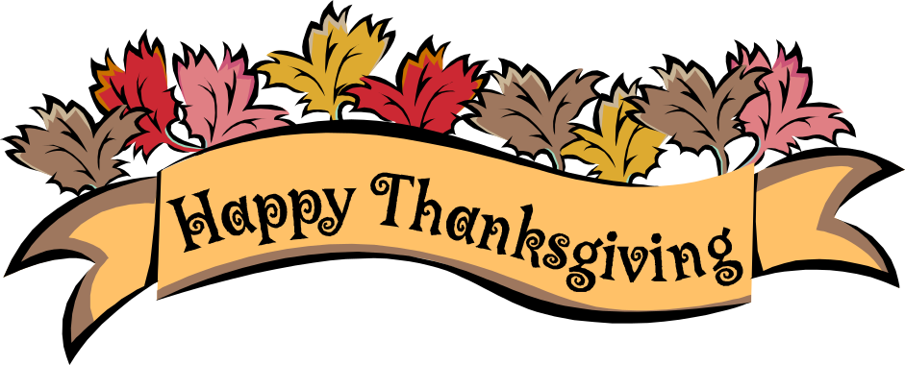

Emma goes to Grandpa’s camp to eat turkey, cranberry sauce, potatoes, dressing and a lot of other great food! Also we had a sleep over with my mom and my sister. Dad was working so we brought him home some apple pie.
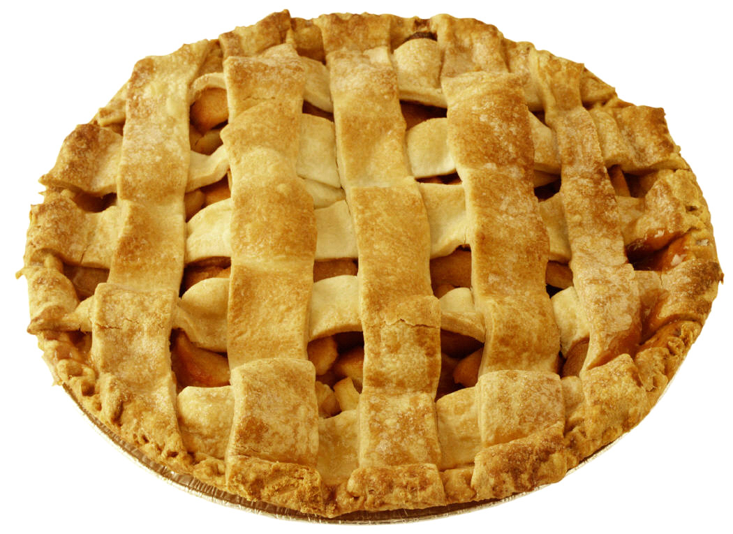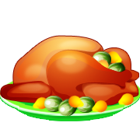

Bryce stays at home with his family and then later on they go over to his grandparent’s house to help celebrate. He had turkey and ice cream for dessert. After eating they went outside to play ball with his brothers.



Taylor has everyone over for turkey dinner. He ate turkey, both dark and light meat, dressing, and potatoes. Over the long weekend Taylor and his dad also went hunting too.
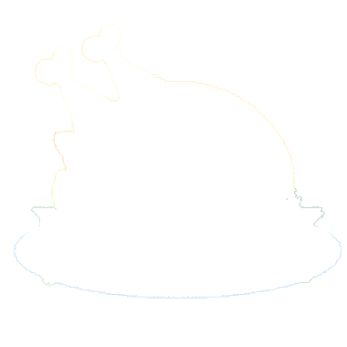

Ty celebrates Thanksgiving at campground with lots of people like his Nan and Pop, his cousins and his mom. In addition, his family eats turkey dinner with potatoes, carrots, stuffing and lots of gravy. Later they play Hide and Go Seek until it gets dark.


Isabella went to Nova Scotia this year for Thanksgiving to visit her cousin. They ate turkey with stuffing and potatoes with gravy. She had lots of fun with her family this Thanksgiving.

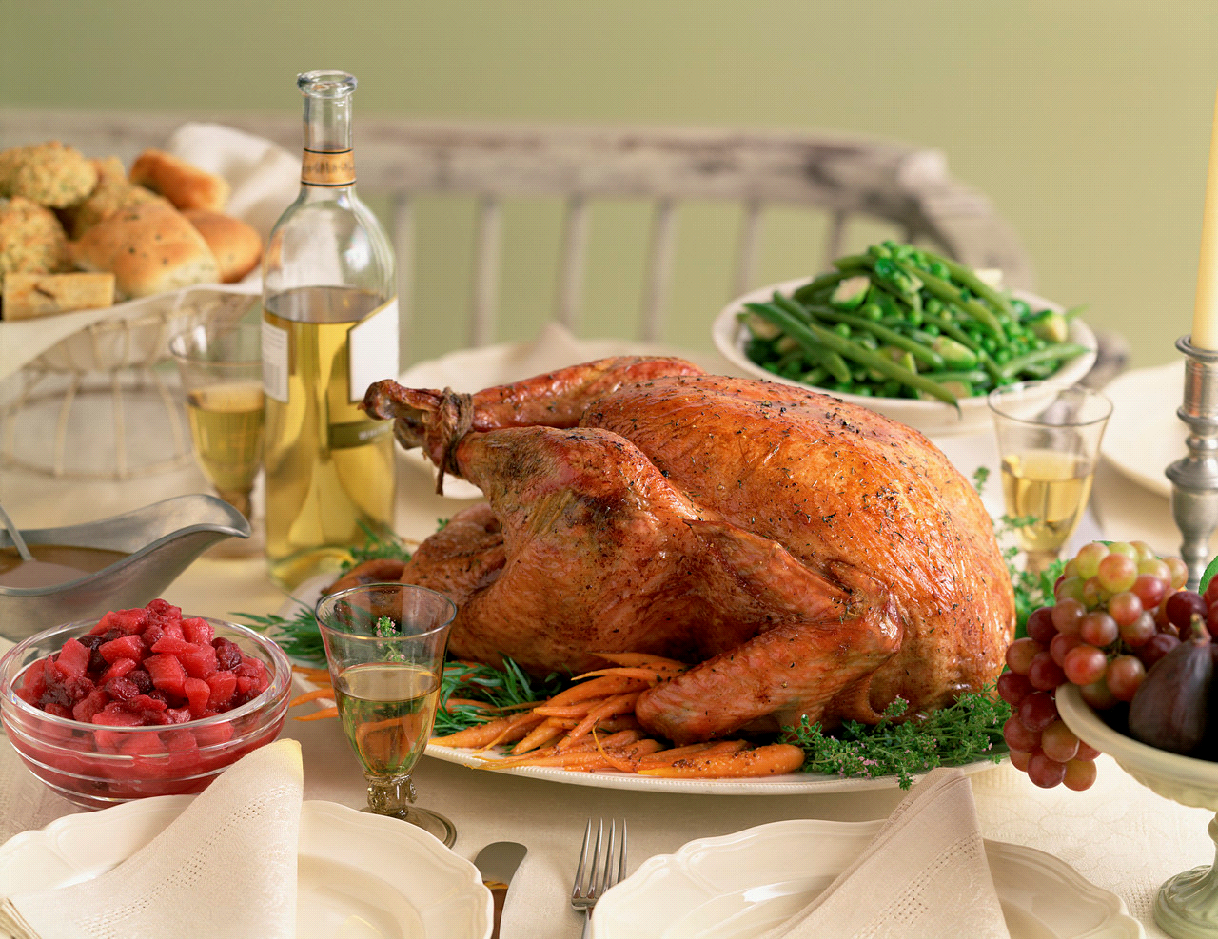

Chelsea went to her Nanny and Goo Goo’s house to celebrate this year with her uncles and aunts and cousins. They ate turkey, potatoes, carrots and cranberry sauce. They have such a big gathering that the kids get to eat at their own table and the adults eat at their own table too.

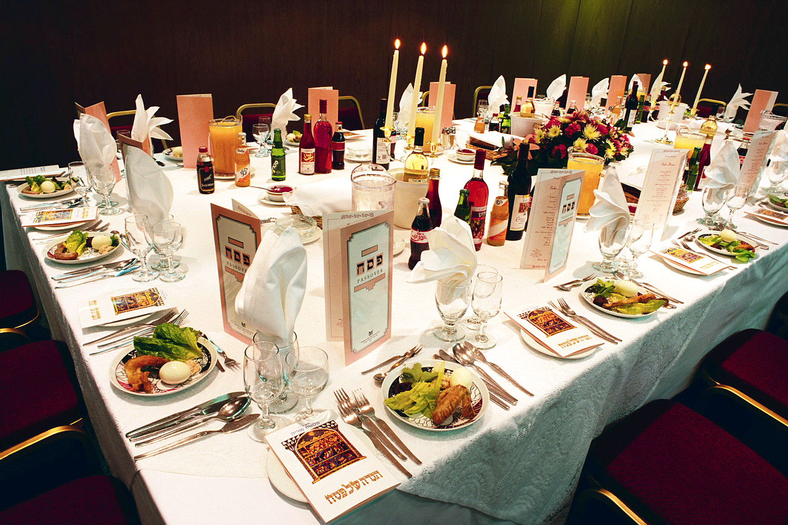

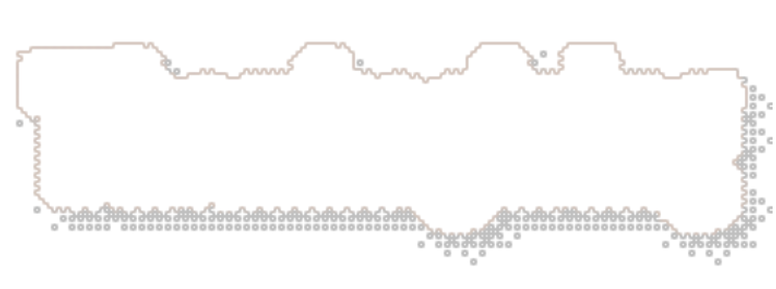

Tori stays at home for Thanksgiving and had lots of turkey – 3 plates full and all the trimmings as well. They ate stuffing and potatoes.



Ethan goes to his Aunt Sharon’s house that just lives down the road from him and they ate turkey, potatoes with gravy and stuffing. Later they went outside to play Freeze Tag.

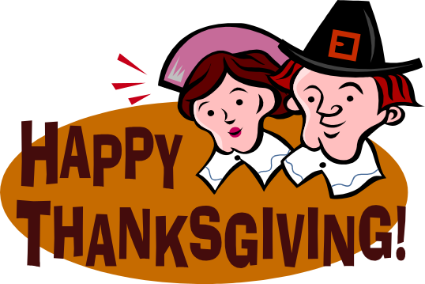

Hannah sits her Aunt’s house and waits for all her family to arrive. They sit and eat at a long table and they had turkey with stuffing, potatoes with gravy, sting beans, turnips and mushroom soup. For dessert, she ate blueberry cheesecake. Yummy! Then they went outside to take some pictures.
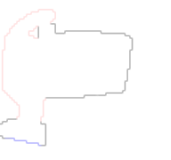

Elizabeth travels to Allie’s house with her family. She ate everything like carrots, potatoes, and two plates of yummy turkey. But she did not like the stuffing so she stuck out her tongue and said it’s gross and everyone laughed.

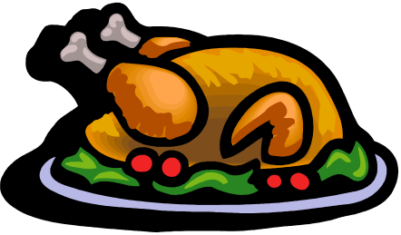

Ava had Thanksgiving dinner with her family. She had turkey, potatoes, stuffing, and carrots. She ate so much that she couldn’t even eat dessert. She has to pass up strawberry shortcake. They all ate at the table since it was Thanksgiving.
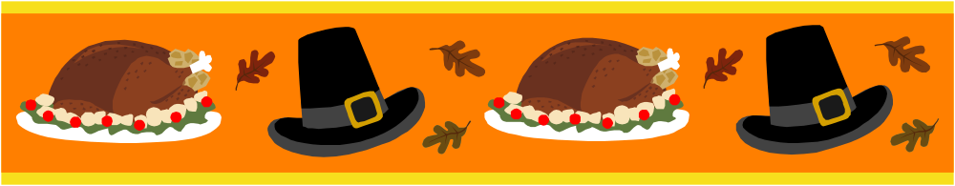

Justin goes to his grandparent’s house to have potatoes, dressing, and turkey. His cousins were there too. After supper they went outside to play Tag and Hunters. Then they ended up climbing in a big tree.

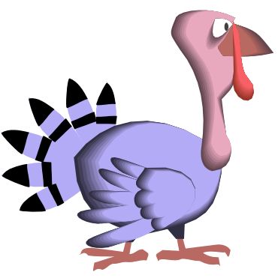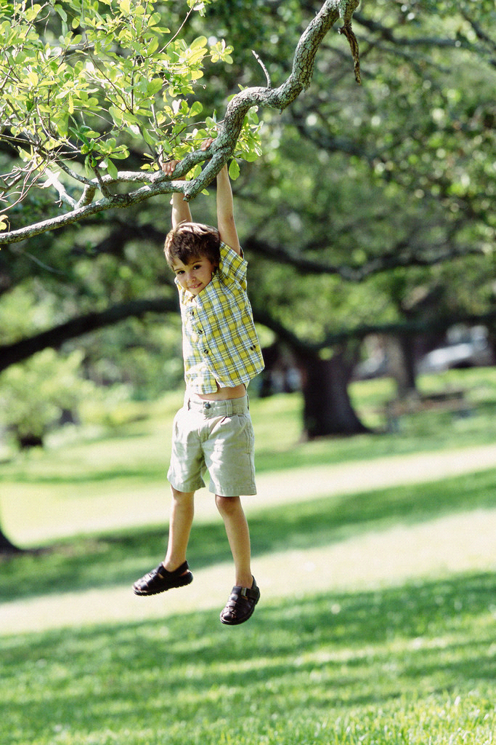


Lillian went to her Aunts and Uncle’s house for Thanksgiving. There were a lot of people and food there so they had to set up three tables. She ate turkey, corn, stuffing, potatoes and peas. Everyone enjoyed their day.

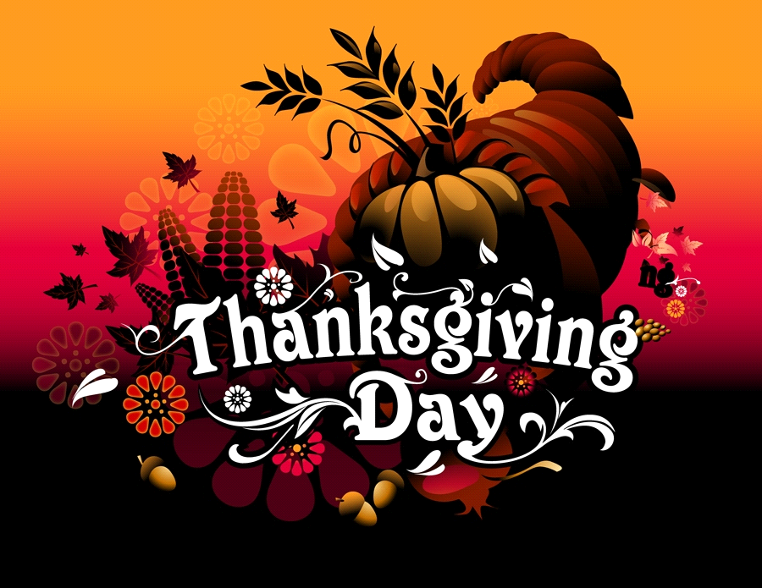

Gobble, Gobble from all the Turkeys in Canada including Mrs. Dickson’s 2nd Grade class.

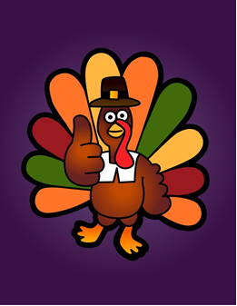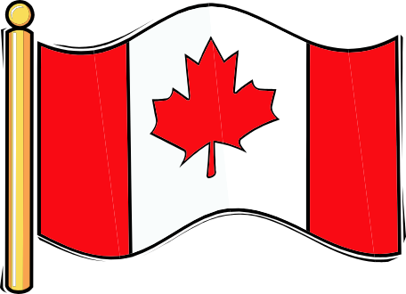

These are just a few ways that we celebrate Thanksgiving in Canada. We cannot wait to see what you do on your special Thanksgiving holiday in Texas.

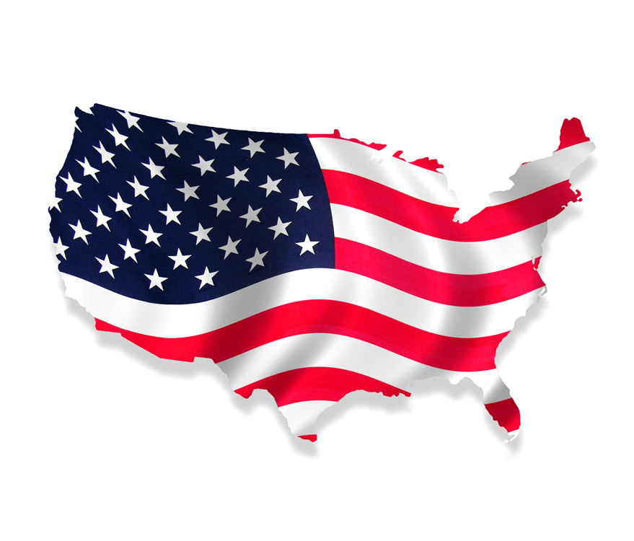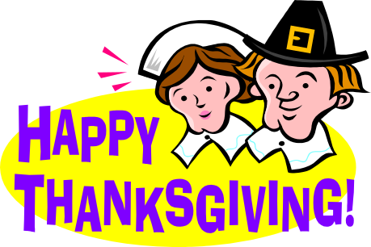



History of Thanksgiving in Canada
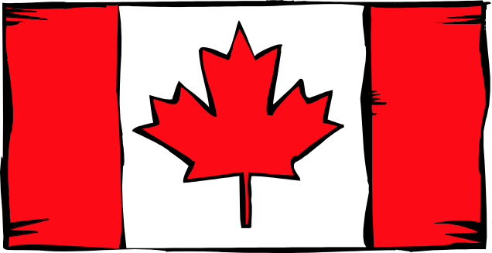

Today people in Canada celebrate Thanksgiving on the second Monday in October. In the beginning, back in 1578 in Newfoundland it was celebrated on a different day. Do you know why? An explorer named Martin Frobisher was thankful for his safe arrival to his new world and this is how Thanksgiving began. Later in 1879,
Canadians started to celebrate Thanksgiving around their harvest so this lead to it being at a different time each year somewhere between late October and early November. Since Remembrance Day is celebrated in November the Canadian Parliament decided to change the day to the second Monday in October so that each holiday would have its own special day to remember it by. So this is how Thanksgiving came to be in Canada.

