Howdy Texas,
We go to Nelson Rural School. We live in Nelson, Miramichi, NB, Canada. Our school has an enormous playground that we play on 3 times per day. We also have a red and blue pirate ship that has a brown steering wheel where we can pretend to be pirates. It sure is a lot of fun! On our playground we have 7 slides. They are red, green, yellow and pink. Some are twisty, some are straight, some are bumpy and the other ones are normal. We really like our red pole which we use to slide down on just like firemen do. Also we have 2 sets of swings too. There are lots of fun activities to do on our playground for sure.

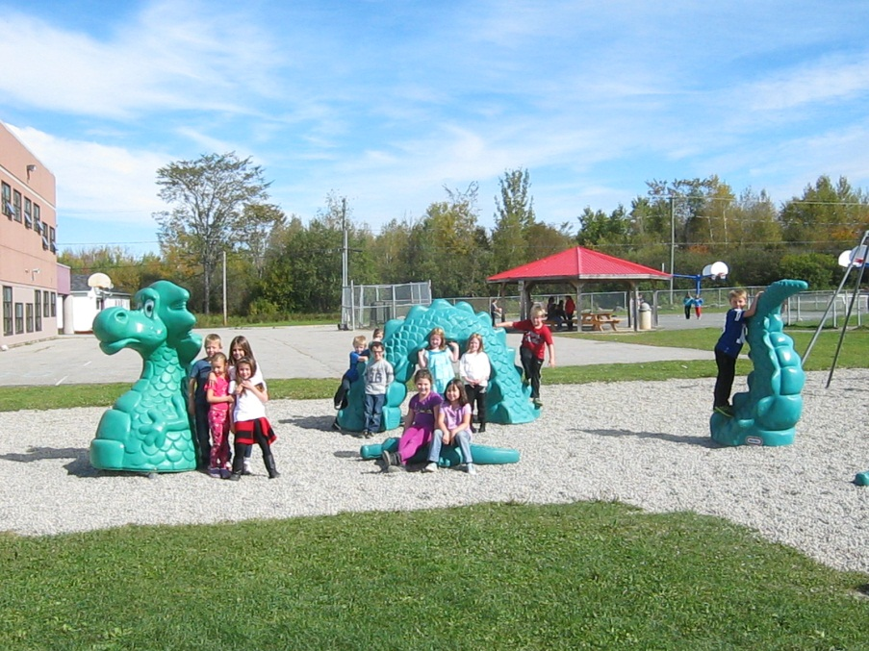
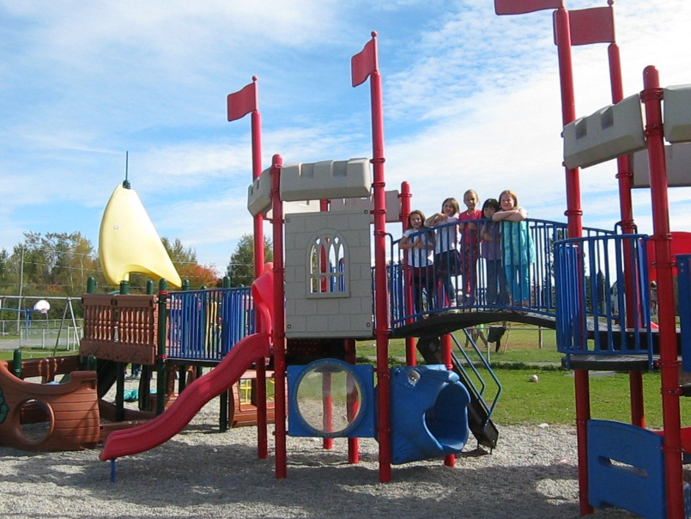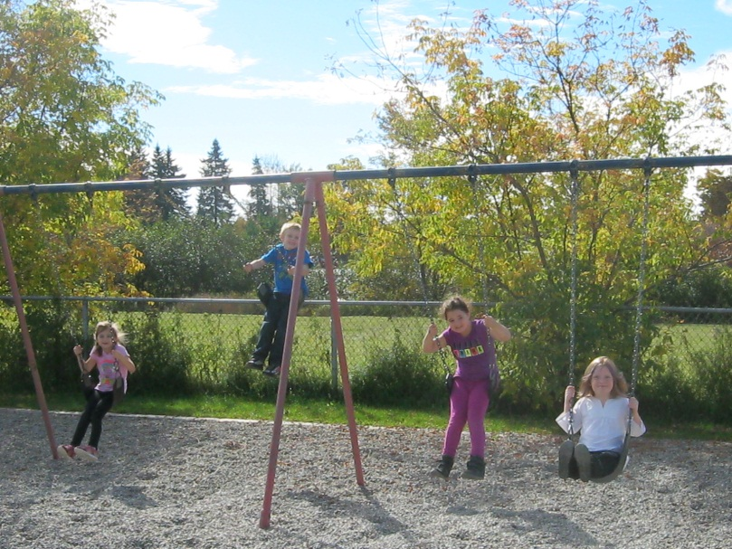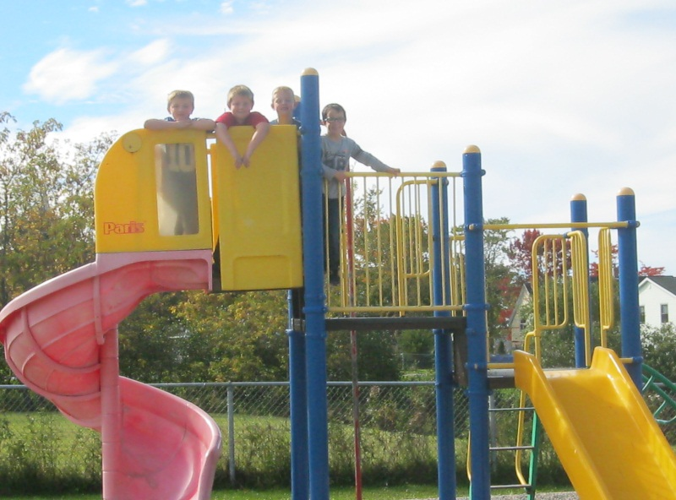

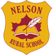

At Nelson we are a K-8 school. We have 303 students and 31 staff members. Also we have a music room, a huge fun gym, a large library, two computer rooms, a science lab and a friendly cafeteria. Our cafeteria has new white lunch tables with benches and we get to look out the window and see our beautiful river.

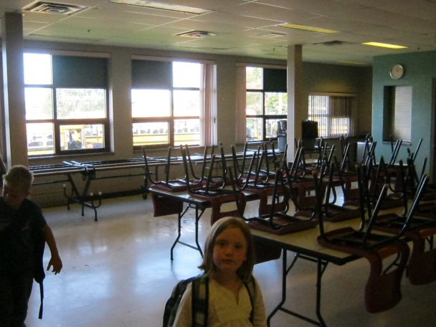
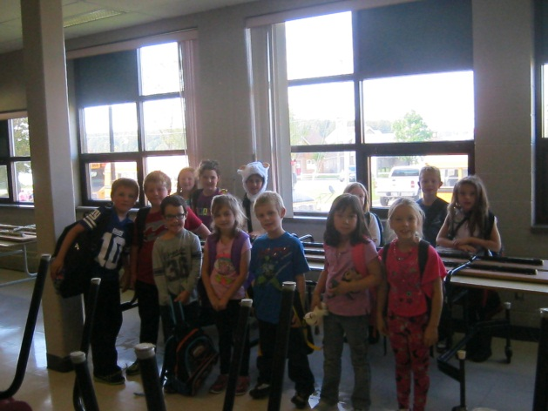
Our teacher’s name is Mrs. Dickson. She is very nice and she is also very tall. In our room we have 13 students and one mascot. There are 5 boys and 8 girls. The boy’s names are: Ty, Bryce, Ethan, Taylor and Justin, The girl’s names are: Isabella, Chelsea, Elizabeth, Emma, Lillian, Ava, Tori and Hannah (Banana). Grape is our mascot. He is a purple stuffed monkey that comes home with someone in our room each Friday. In our room we have Scribbles, a stuffed octopus, who helps us to learn how to write. We also have a Smartboard, 2 large shelves of books, 13 student desks, one teacher desk, a blue Guided Reading table and some cubbies for our supplies. During our day we learn about Art, Reading, Writing, Music, Gym, Math and You and Your World. We start our school day at 8:00 am and we finish at 2:00 pm.

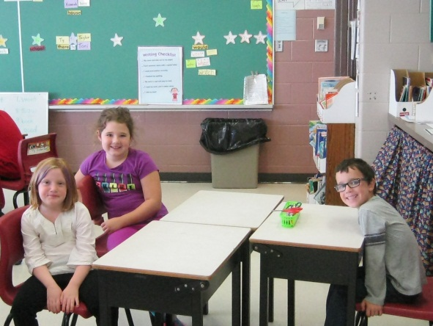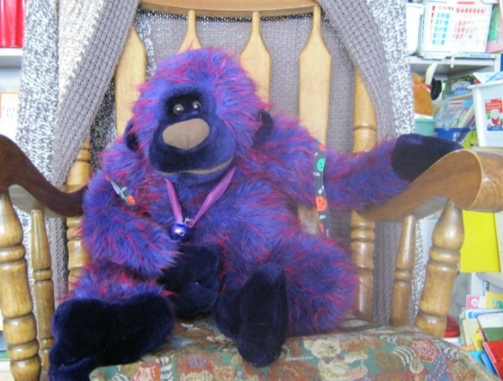
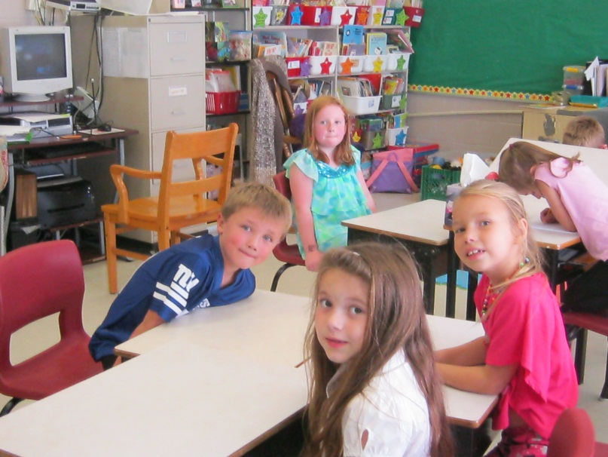
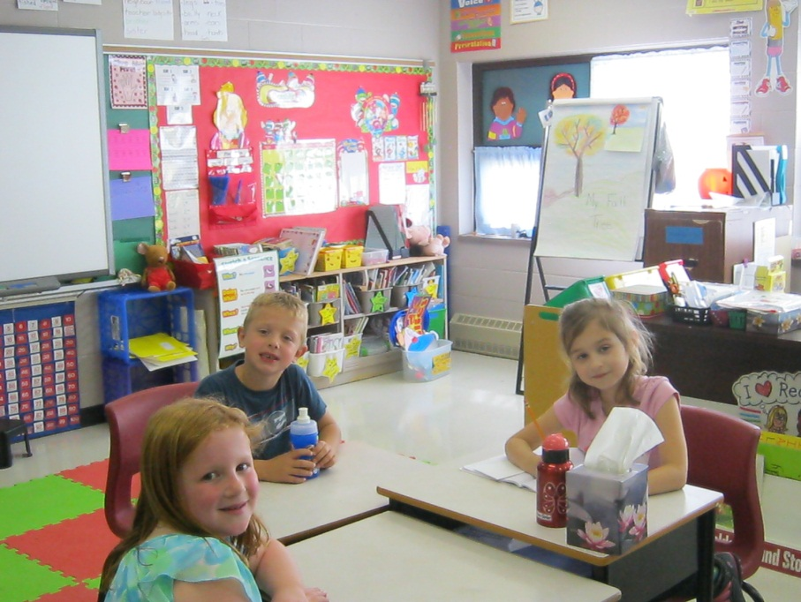
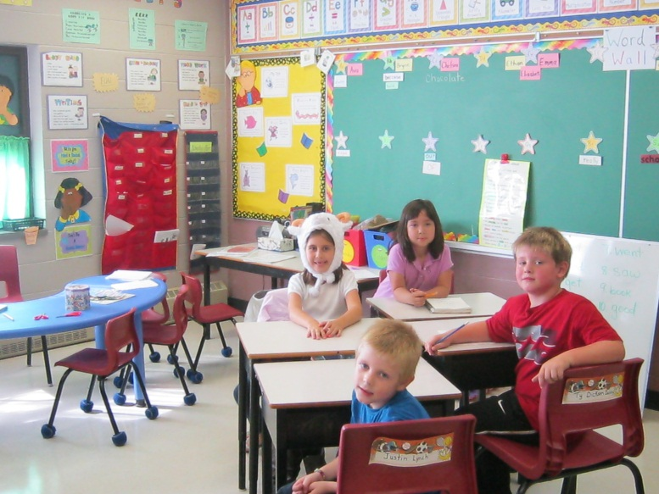
In Canada, we have 4 seasons. Right now it is the end of our summer and soon to be Fall. Our temperatures are around 14 degrees Celsius or 57 degrees Fahrenheit. We have to wear a coat or warm sweat top to school in the mornings to make sure we are warm. In the mornings it is still dark and it is getting colder too. When we get home from school around supper time it is beginning to get dark also. This is another sign of Fall. Also at night time the air becomes cooler, but our afternoons are warm still.
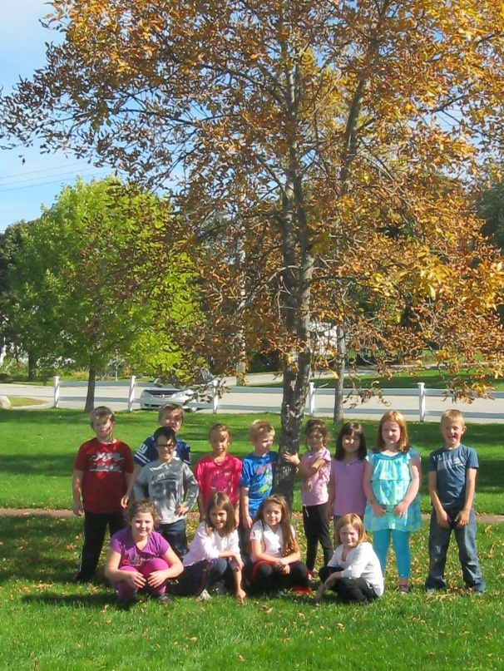
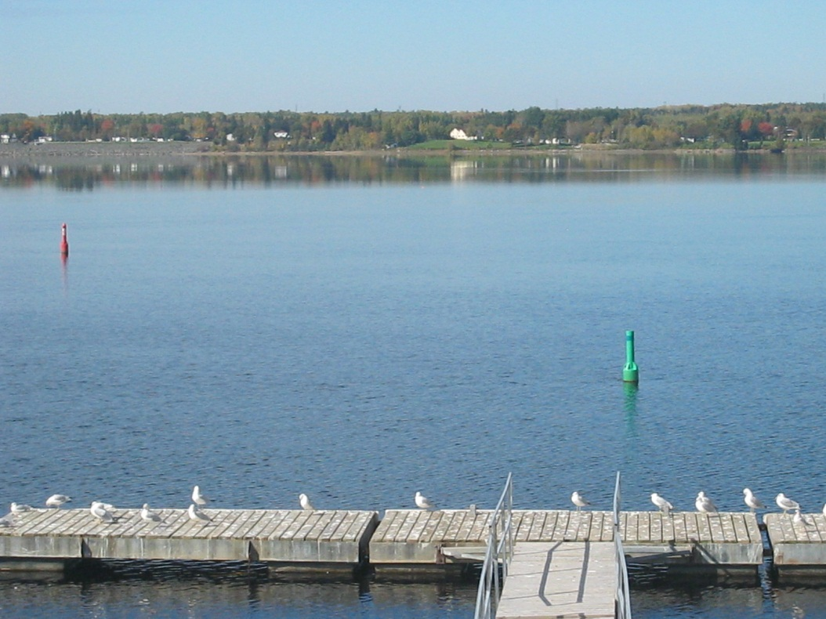

We are lucky because our school is located next to a beautiful river called “The Miramichi River”. In the river right now are some boats, ducks and Canadian geese. Soon our river will freeze over and we will see ski-doos and people out there having fun being active. The leaves on the trees are also changing colors and the view all around us is breath taking with all the wonderful colors.

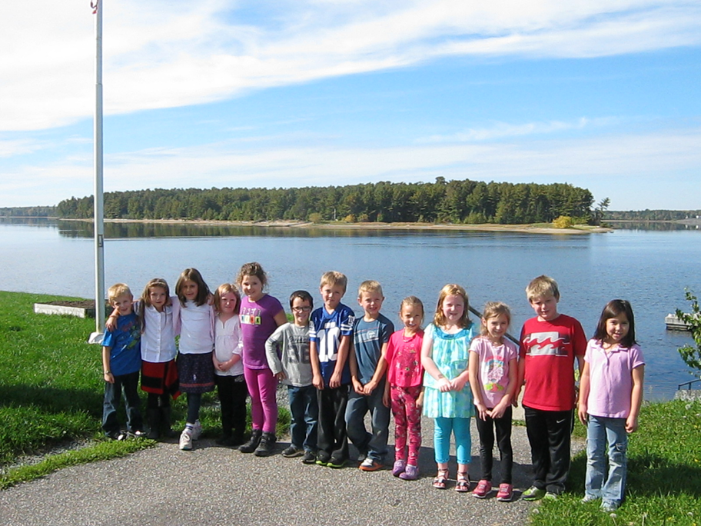
At Nelson Rural School we love it so much because of our wonderful teachers who love us and look after us well, we have a great big playground, a magnificent view of the river and we have lots of fun learning at our school.

