**Christmas Traditions in Canada**

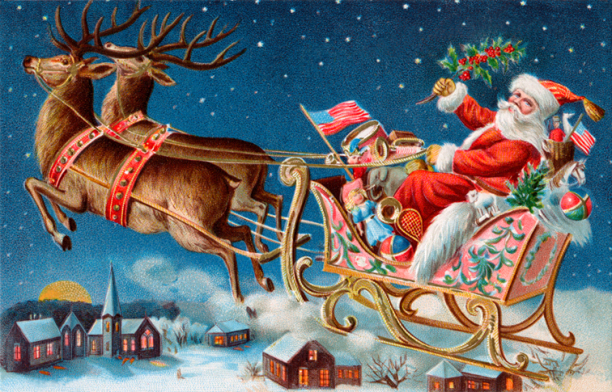

**Here are our Christmas Traditions from each of the students in Mrs. Dickson’s grade two class this year. Hope you have a fun filled and relaxing break in Dallas, Texas as well.**

**Isabella – Every year we put up our Christmas tree in the corner of our living room. The Christmas ornaments on our tree are red, blue and silver. There are also white lights and a star on top. This year Elf on the Shelf arrived at our home. His name is Buddy. I’m very excited to celebrate Christmas with my family.** 

**Ty – On Christmas Eve my dad and I have a Christmas dinner every year! We have turkey, potatoes, stuffing and cranberries. YUM! I was wondering if you had a Christmas dinner on Christmas Eve? By the way hope Santa finds you!**



**Tori – I put up a tree and decorate it. We always have a party on Christmas Eve. I also open one present on Christmas Eve too.**



**Hannah – These are my Christmas traditions. On Christmas Eve we go to church and then we go to my grandmother’s house to open presents. On Christmas day we go to my grandmother’s again to eat turkey dinner.**



**Ava – We pick out a tree for Christmas and the decorations together. We also make a gingerbread house every year. Mom makes our stockings too. We also wrap our presents to make them look special with lots of ribbons. I go on sleigh rides every Christmas also.**

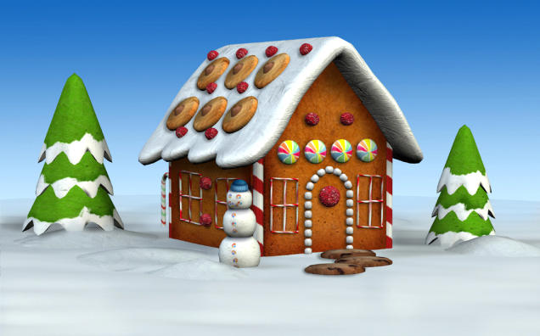

**Chelsea – We get up in the morning and open presents and then have dinner with our family at my Grandparent’s house.**



**Taylor – Every Christmas we always wait until everyone is awake to open our presents and then we have a big feast at our kitchen table in our living room.**



**Lillian – Every year we put a Christmas tree up outside and inside. We go to my aunt Helen and Uncle Richard’s house for supper. On Christmas morning my Nanny and Aunt Marlene come for breakfast and watch me open my presents.**



**Ethan – My family traditions are having fun and spending time together. We go to church on Christmas Eve and after we go to Aunt Sharon’s house. Then I go home and leave out cookies and milk for Santa. I get up in the morning to see what Santa left for me. The rest of the day we visit our family.** 

**Justin – My family traditions are going to my grandparent’s on Christmas Eve to open our presents and spending time with our family.**



**Emma – My family tradition is to send money to a charity every Christmas. What is your family tradition? Last year I sent $10.** 

**Bryce – At Christmas time two Elves on the Shelf came to our house. Their names are Bell and Jingles.**



**Elizabeth – Every year two weeks before Christmas we have a party with our whole family called a Soiree. We all dance and sing.**



**Mrs. Dickson – Each year we go to church and then return to my mom and dad’s house to eat and dream about what Santa might bring us in the morning. Later we rush home to sprinkle reindeer food over the front lawn or snow to help guide the reindeer to my house. Also we leave out milk and cookies for Santa. Just before we go to bed we put on our Christmas PJ’s and open one gift.**



**Hope you all have as much fun as we do up here in Canada waiting for Christmas to come. Merry Christmas and Happy New Year to y’all!**