Howdy Buddies!

We are excited about being your pen pals this year! We would like to share some things about our school and city.

We go to St. John’s Episcopal School in Dallas, Texas. Our school has pre-K through 8th grade. We have about 500 students. Our teacher’s name is Mrs. Booth. We have 16 students in our class: 8 boys and 8 girls. Our names are: Toby, Nate, Abby, Liam, Brooke, Ian, Ben, Andrew, Claudya, Gretchen, Mia, Meghan, Quinn, Lauren, Archer, and Katy.
We study math, science, social studies, language arts, and handwriting. We have a lot of fun and learn a lot in our enrichment classes. Our enrichment classes are: Spanish, music, choir, art, P.E., and computer. We eat lunch in the cafeteria each day. Sometimes we buy our lunch and sometimes we bring our lunch from home.

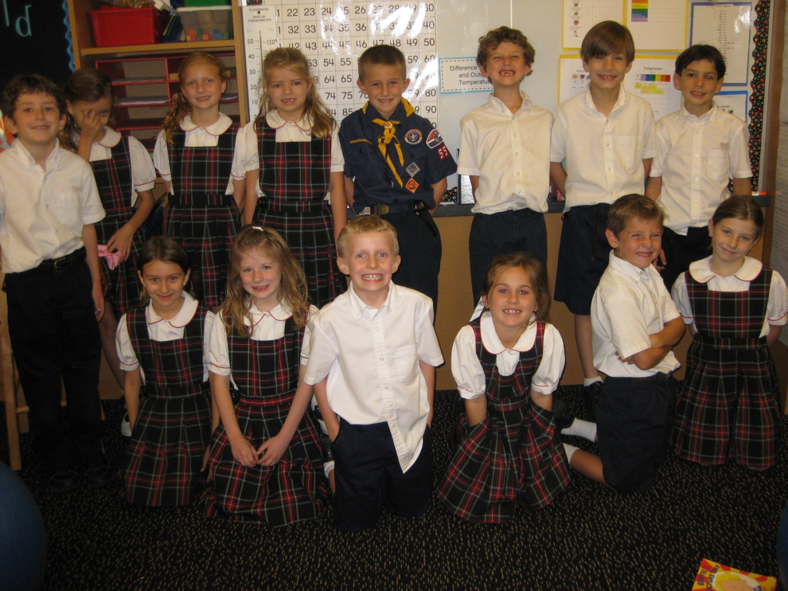

This is a picture of us in our classroom. We have a class pet named Hot Chocolate. He is a guinea pig. He likes to eat hay, carrots, grass, and parsley. He drinks lots of water. Different students feed him each week. His eyes are red.
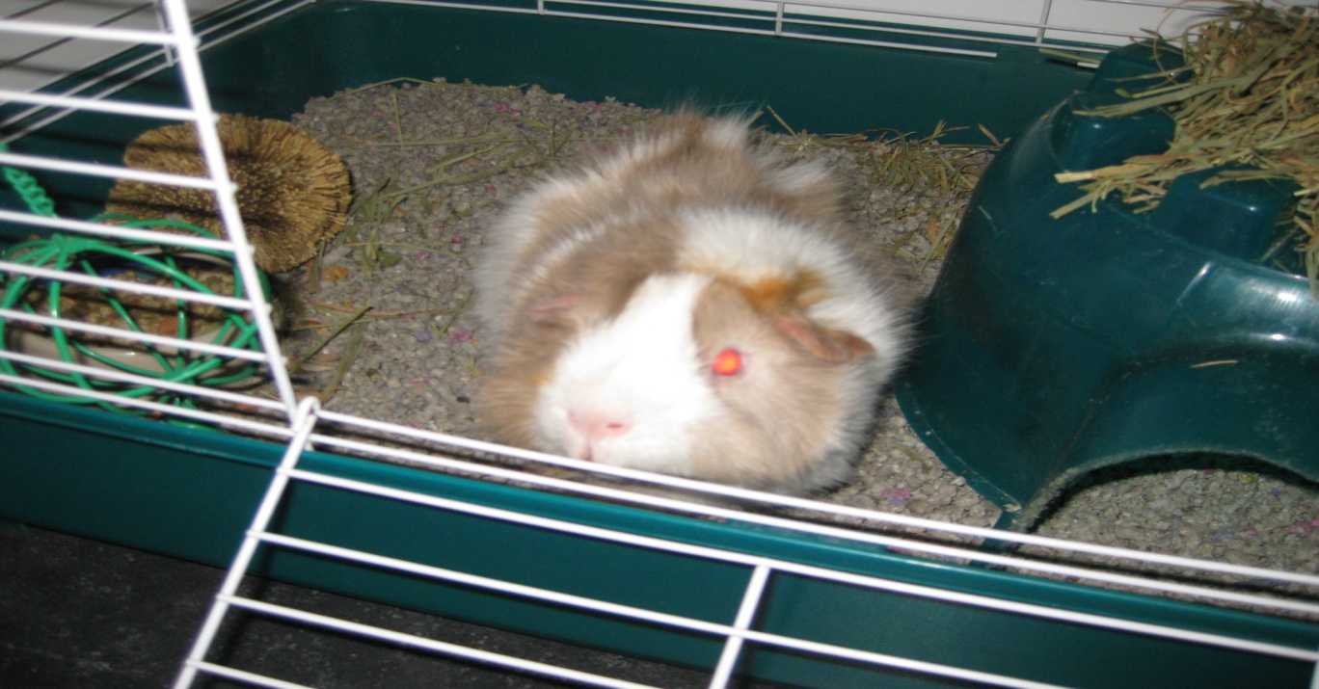

We also have lots of books in our classroom. We have avocado pits that we are trying to root. We have a Smartboard that we use for math, calendar activities, Crusader Live, Grammar Rocks, and to skype with you! Our classroom jobs change each week. Our class has recess and P.E. every day. We have two playgrounds with swings, slides, and tunnels. The school also has a soccer field and basketball court.

Dallas has a big downtown with lots of tall buildings. We also have the State Fair of Texas. Big Tex welcomes everyone to the fair with a big “Howdy Y’all.” Our favorite ride at the fair is the Crazy Mouse. We also like to play games and win big prizes, go to the Fun House, go to the pig races, listen to music, and go to the petting zoo. We also like to eat at the fair. Our favorite fair foods are corny dogs, fried oreos, Texas chips, funnel cakes, and fried frito pie. It is a good thing the fairs happens only once a year!
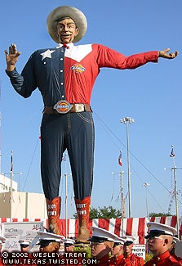

Today we had our Play With Your Food Art Show. We each made a character out of fruits and vegetables. We had a lot of fun doing it and can’t wait to share our pictures with you!

We are looking forward to our next meeting!

Your friends,
Toby, Nate, Abby, Liam, Brooke, Ian, Ben, Andrew, Claudya, Gretchen, Mia, Meghan, Quinn, Lauren, Archer, Katy, Hot Chocolate, and Mrs. Booth

