Howdy Texas,

This year we are in grade three and we are very excited to be able to participate with you in our pen pal and tulip exchange. Our names are Brody, Dylan, Wyatt, Eddy, Jorja, Shelden, Josh, Nicholas, Jaielyn, Sarah, Brooke, Jenna, Emily M, Emily O, Cody, Tanner, Emily V, Adam and Gracie. Oh yeah there is our teacher Mrs. Dickson and our Educational Assistant Mrs. Alward too.

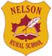

We go to Nelson Rural School and we have about 314 students in our building. Our grades go from kindergarten to grade 8 and our building is two stories high.
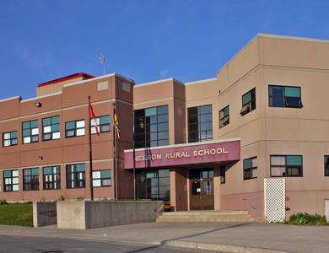
At Nelson our playground has two parts. One part is for the K-2 students and it is cool as it has a pirate ship, a green sea serpent, three green alligators, swings, diggers, a few slides and a fire pole. This part of the playground is named after a former student who died and his name is Thomas Woods. His brothers and sisters are still at our school.
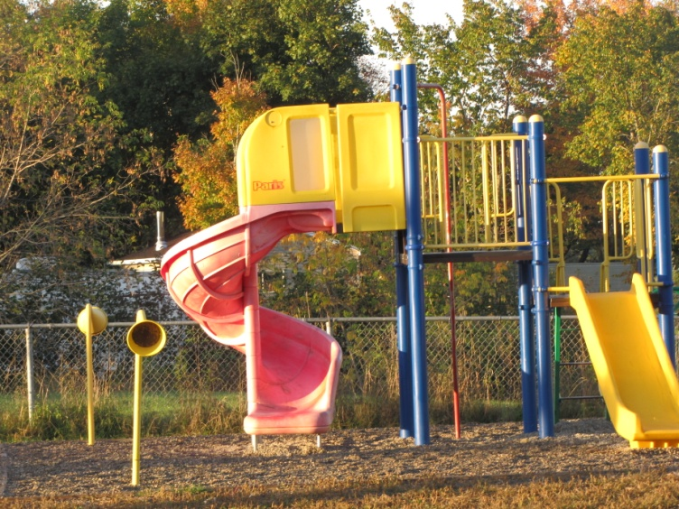

The bigger kid’s playground has one yellow and one red set of monkey bars, big swings, teeter-totters, basketball courts, a soccer field, bar sliders for your feet, and a huge yellow spider. What does your play ground look like?
Our school takes pride in doing well at the many sporting events it takes part in. We get to participate in Cross country running, soccer, basketball, volleyball. Softball and finally in the spring we do Track and Field. Sometimes we do cross country skiing, hockey and archery too.
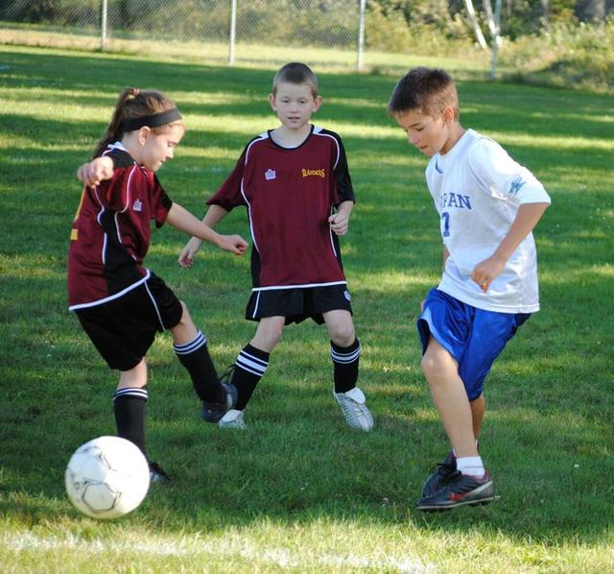
Our school is in front of the beautiful Miramichi River. Right now the water is cold but it soon will freeze over in the winter. During the winter we can walk on the river, skate, and play pond hockey. Snowmobile, ski or go ice fishing. Later in the spring the ice breaks up and floats away in large chunks. Then the ducks and birds return and in late June we can swim, water ski, go boating or tubing, fish or just watch the sun reflect off the shimmering water. We enjoy our river all year long.
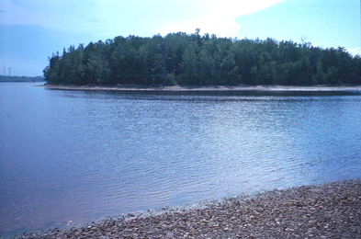

Last year our classroom was a grade two class, but this year it is a grade three room. In our room we have tons of great books that we read every day. Also we have a Smartboard that we use for all our subjects and to talk to you too. Next we have a vocabulary chart that we add our BIG words we want to use in our writing or when we are speaking so we sound even smarter than we already are. Right now we are studying Magnets in science class and we have done many fun experiments!! Finally we have a birthday chart which reminds us of when we all have our special birthdays.

In our school we have some special rooms like our cafeteria, the library, two computer labs, our gym, the science lab, our music room and our small room we use to do our important test in. Also we have many classrooms where we spend most of our days.

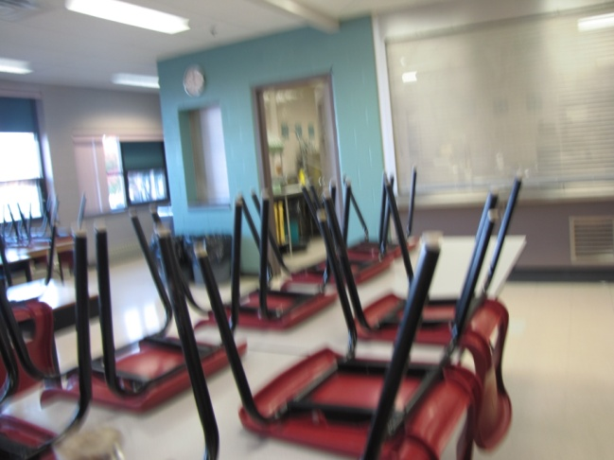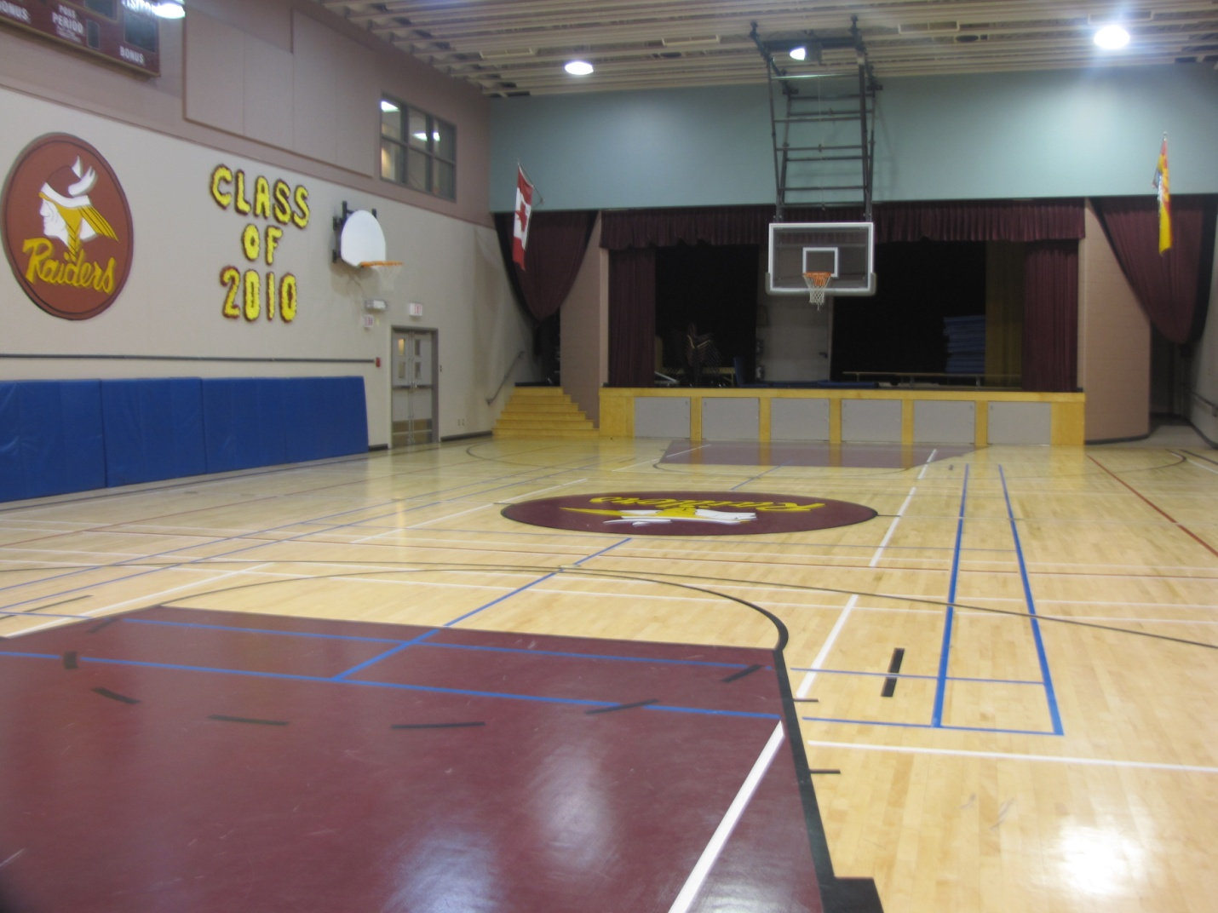
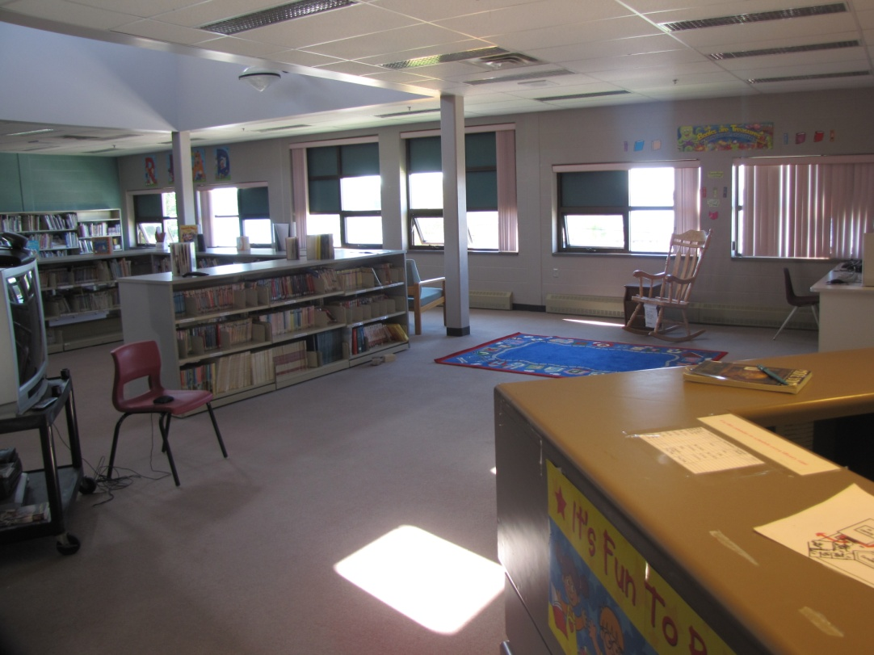

So now you can see why we think our school is awesome! We also have an amazing time at our school because we feel special and loved! How do you feel about your school?

