Oct. 4, 2010
Dear Mrs.Dickson’s Class,
Howdy friends in Canada! We are the students in Mrs. Crabtree’s Second Grade Class. We have 11 girls and 7 boys in our class of 18 students. Our names are Carter, Caitlin, Donovan, Stella, Hannah, Jayce, Peyton, Hayden, Mia, Ben, Sophia, Bella, Will, Isala, Luke, Kori, Henry, and Eva. We are excited to write letters and begin doing weather reports with you soon as well as beginning the tulip project!
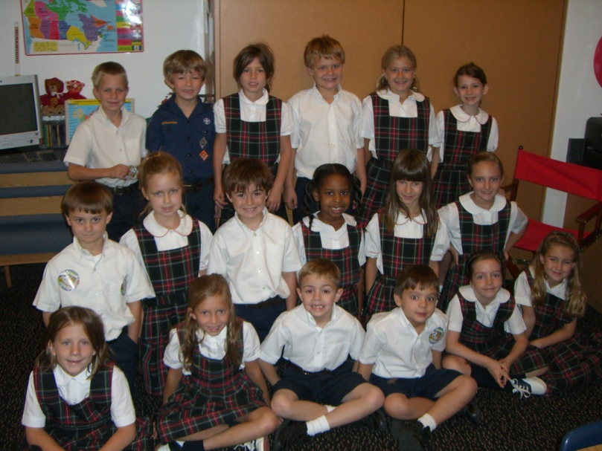
We go to St. John’s Episcopal School in Dallas, Texas. We have a new Head of School this year named Mr. Crotty. Mrs. Binford is our Lower School Head and Mrs. Kohl is the Upper School Head.
Sugar is a brown and white Dwarf Hamster that lives in our classroom. Sugar likes running around in her cage. Sugar is so soft. Each weekend one of us gets to take her home to visit and we can write about her journeys. For good behavior and class compliments our class can earn letters to spell the word hamster. Then on Friday we get to sit in a circle and Sugar gets to roll around in her ball to music.
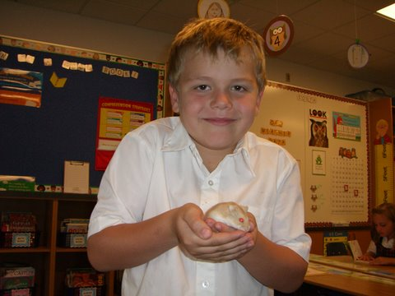
Each morning we get to watch Crusader Live on our Smart Board. It is where we hear the morning announcements, and see short video clips produced by the students of what is going on at our school. When it is over we say the Pledge of Allegiance. In our Scholastic News the other day we compared your Canadian flag to the U.S. flag. We noticed that your flag has red and white stripes like ours, and you have three stripes while we have 13.

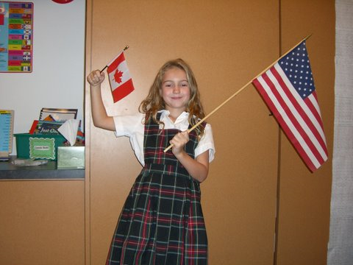
At our school we must wear uniforms. The boys’ uniforms are white collared shirts, with blue pants or shorts, a belt, and black shoes. The girls’ uniform is a plaid jumper with a white collared shirt and saddle oxford shoes.
We go to chapel each morning after the announcements. On Friday we have chapel that is an hour long because we have Eucharist where we can receive a blessing, bread, or wine. If it is a student’s birthday they get to go up to the front of the chapel and receive a blessing. They may also bring in cookies, cupcakes, or doughnuts to share with the class in our room that afternoon.
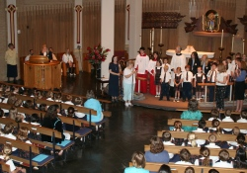
Each morning we begin our day in the classroom by doing calendar. Calendar is just one of our many classroom jobs. We also have Cuisine Captain, Table Cleaner #1, Table Cleaner #2, Door Holder #1, Door Holder #2, Critter Care, Poetry Picker, Teacher Helper #1, Teacher Helper #2, Weather, Temperature, Attendance, Caboose, Reporter, Shelf Elf, Line Leader, Pencil Sharpener. The Pencil Sharpener gets to sharpen pencils in the electric pencil sharpener at the end of the day. Shelf Elf gets to takes the books to the library when people forget to bring them back on the Wednesday that they are due. They also keep our classroom library neat!
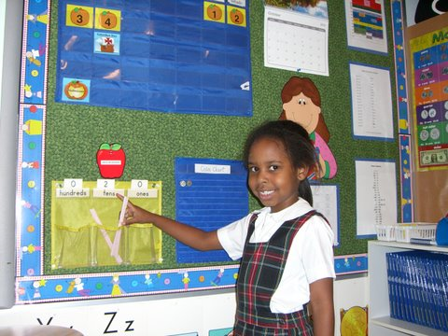

In the morning we usually have handwriting, word study, and reader’s and writer’s workshop. Then we go to recess and lunch. In the afternoon we have math, science, and social studies. In math we get to work on number scrolls where we can practice writing really big numbers on a scroll. We just made a class one that we worked together on with partners which went to the number 1,000! In math we also do Math Boxes daily where we review and practice math skills we have already learned. Many of us also have fun doing these fun wipe off math cards when we are finished that have additional math games, puzzles, and skills on them.
Each night we have 3 assignments for homework. On Fridays we can earn a sticker for an Excellent Extra Reading Chart for each extra 30 minutes we read for homework. After we earn 10 stickers we can choose a new book to keep from Mrs. Crabtree’s book basket.
We have many fun enrichment classes that we get to go to each week to at St. John’s. We have Art where we can paint pictures. We also go to P.E. where we get to play fun games. We have Music where we get to play singing games. We also go to Spanish where we learn fun Spanish words and play games. We have library check out on Thursdays and since we are in 2nd grade we can check out 2 books!
On Tuesdays we call it “Terrific Tuesday” because we get to have a morning and an extra afternoon recess. We usually just get one recess in the morning. When it is rainy outside we have lots of fun things in our classroom to play with such as Legos, draw pictures, listen to books on compact discs, watch Sugar, build marble runs, and play board games.
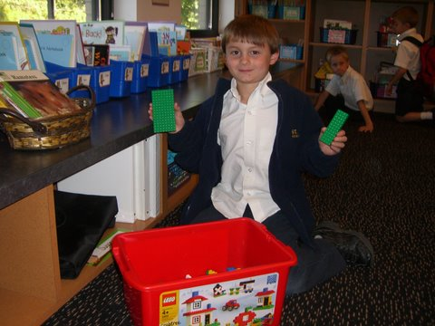
At the end of the day we go home in carpool. We look for our names to pop up on the Smart Board and then we know our ride is here and we can leave. Sometimes we have to wait longer if we have an older sibling since there are 3 carpool times!
We hope you enjoyed learning a little about our class. We can’t wait to learn more about each one of you through writing our pen pal letters!
With love from your Texas Buddies,
Mrs. Crabtree’s 2nd Grade Class

